
Data Structures and Algorithms (23CSE203)
LAB MANUAL
Submitted By:

Name | R . Hasini shekhar
Roll No | AV.SC.U4CSE25146
Year/Sem/Section | 2nd YEAR/SEM-3/CSE-B
Date of Submission:
Submitted To:
Name | Dr. Raj Kumar Batchu
Department | CSE
Designation | Assistant Professor (Sl. Gr) School of Computing

MARKS

S. No | TITLE | PAGE NO | REMARKS
1. | 1(A) Aim:  A rocket launch system displays countdown before launch . Using recursion write python program to display countdown to 1 followed by launch.  1(B) Aim:  Write a python program to calculate compound interest by taking user input.  1(C) Aim:  HR Department stores Employee Id’s in a list develop a recursive program in python to search for a given employee Id in the list.  1(D) Aim:  Develop a python program to print 1st n terms of Fibonacci series.  1(E) Aim:  Develop a python program to calculate factorial of a given number. | 9–20
2. | 2(A) Aim:  Write a python program to implement linear search.  2(B)(i) Aim: Write a python program to implement binary search with sorted array as input.  (ii) Aim: Write a python program to implement binary search with unsorted array as input. | 21–27
3. | 3(A) Aim:  Write a python program to apply insertion sort where input elements are taken from the user .  3(B) Aim:  Write a python program to apply bubble sort where input elements are taken from the user .  3(C) Aim:  Write a python program to apply selection sort where input elements are taken from the user . | 28–32
4. | 4(A) Aim:  4(A) Aim:  write a python program to implement merge sort, where the elements are taken from user.  4(B) Aim:  write a python program to implement quick sort, where the elements are taken from user. | 33–38
5. | 5(A) Aim:  Write a python program to implement a single linked list with the below operations:  A. create linked list  B. insert at beginning  C. Insert at end  D. Insert at index  E. Delete by value  F. Delete first node  G. Delete last node  H. Count number of nodes I. Display/traverse  J. exit  5(B) Aim:  Write a python program to implement a double linked list with the below operations:  A. create linked list  B. insert at beginning  C. Insert at end  D. Insert at index  E. Delete by value  F. Delete first node  G. Delete last node  H. Count number of nodes  I. Display/traverse  J. exit  5(C) Aim  Write a python program to implement a circular linked list with the below operations:  A. create linked list  B. insert at beginning  C. Insert at end  D. Insert at index  E. Delete by value  F. Delete first node  G. Delete last node  H. Count number of nodes  I. Display/traverse  J. exit | 39–51
6. | 6(A) Aim  Write a python program to implement stack operations such as push, pop, peek, display using an linked list.  6(B) Aim  Write a python program to implement stack operations such as push, pop, peek, display using array. | 52–60
7. | 7(A) Aim  Write a python program to implement queue and its operations such as enqueue, dequeue, peek and display with a menu driven approach using an array.  7(B) Aim  Write a python program to implement queue and its operations such as enqueue, dequeue, peek and display with a menu driven approach using linked list.  7(C) Aim  Write a python program to implement circular queue and its operations such as enqueue, dequeue, peek and display with a menu driven approach using an array.  7(D) Aim  Write a python program to implement circular queue and its operations such as enqueue, dequeue, peek and display with a menu driven approach using linked list. | 61–78
8. | 8(A) Aim  write a python program to implement a binary tree with its operations using an array:  8(B) Aim  write a python program to implement a binary tree with its operations using Linked list: | 79–86
9. | 9(A) Aim  write a python program to implement a binary search tree with its operations and traversals: | 87–97
10. | 10(A) Aim  write a python program to implement an binary AVL tree with its operations | 98–106

LAB-1:
1.)Basic Programs Using Recursions :
A.) Aim: A rocket launch system displays countdown before launch . Using recursion write python program to display countdown to 1 followed by launch.
Program:
def rocket_countdown(n):
if n == 0:
print("LAUNCHED! ")
return
print(n)
rocket_countdown(n - 1)
start_num = int(input("Enter starting countdown number: "))

print("\n--- Starting Countdown ---")
rocket_countdown(start_num)

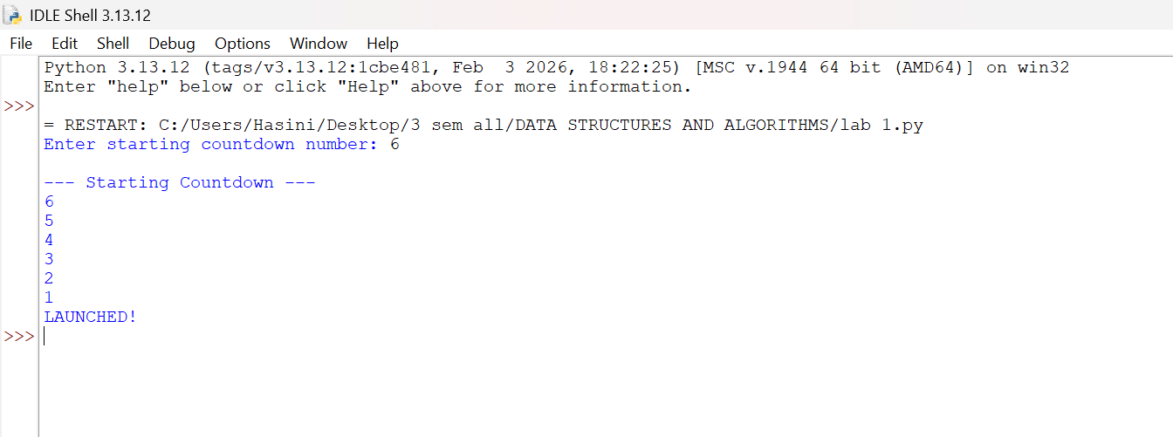
Output(+Ve Case):

Output(-Ve Case): 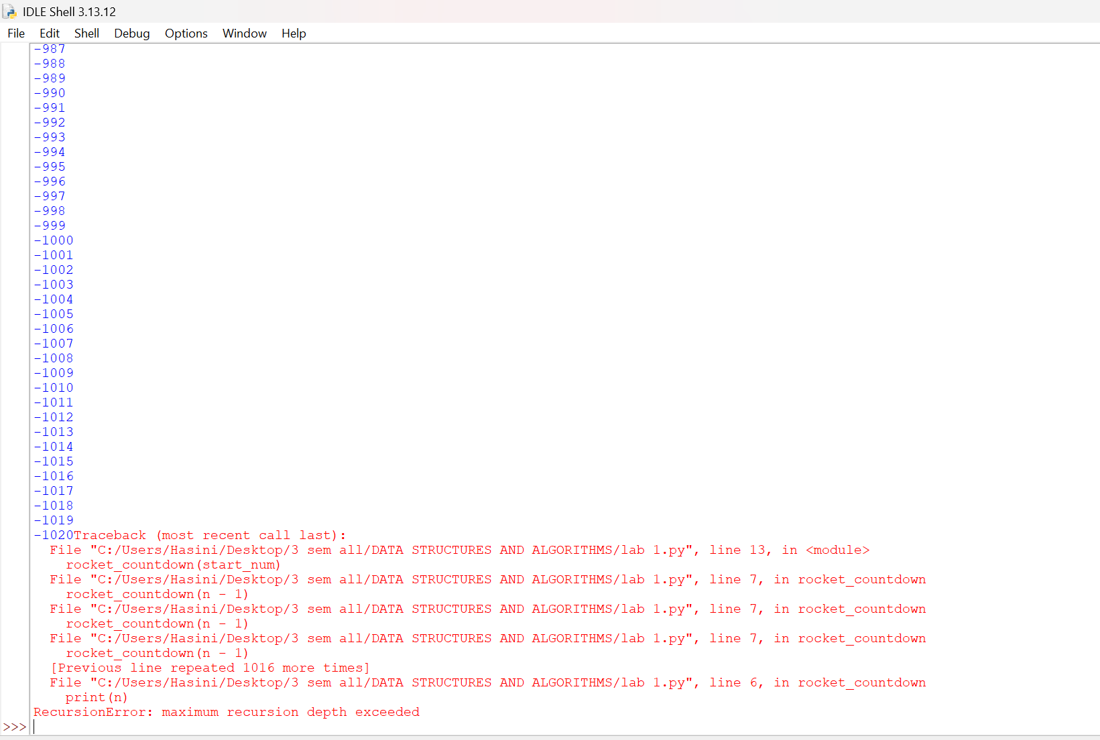

Error Table
S.No. | Error type | Error / Mistake | Reason | Correction
1 | Syntax Error | Missing : after if n == 0 | Python requires a colon after an if statement. | Write if n == 0:
2 | Syntax Error | Missing : after def rocket_countdown(n) | Function definitions must end with a colon. | Write def rocket_countdown(n):
3 | Indentation Error | Incorrect indentation inside the function | Python uses indentation to define code blocks. | Indent the statements inside the function properly.
4 | Name Error | Writing rocket_countdown() instead of rocket_countdown(start_num) | The function requires an argument. | Pass start_num as the argument.
5 | Runtime Error | Entering a non-numeric value as input | int() cannot convert text such as abc into an integer. | Enter a valid integer.
6 | Logical Error | Using if n == 1 as the base case without handling the launch message correctly | The countdown may stop before displaying the intended output. | Use if n == 0: to print LAUNCHED! after counting down to 1.

Explanation
The function rocket_countdown(n) displays the countdown using recursion.
The base case checks whether n is equal to 0.
When n is 0, the program prints “LAUNCHED!” and stops.
Otherwise, the current value of n is printed.
The function calls itself with n - 1 to continue the countdown.
The user enters the starting number, and the countdown begins.

B.) Aim: Write a python program to calculate compound interest by taking user input.
Program:
def C_Int(p,n,r,t):
decimal_rate = r/100
total_amount = p*(1+decimal_rate/n)**(n*t)
interest_earned = total_amount - p
return total_amount, interest_earned
p = int(input("Enter the principal amount (₹) : "))
n = int(input("Times compounded per year : "))
r = float(input("Enter the annual interest rate (%) : "))
t = float(input("Enter the number of years : "))
final_balance, pure_interest = C_Int(p, n, r, t)
print("\n--- Financial Breakdown ---")
print(f"Interest Earned: ₹{pure_interest:.2f}")
print(f"Total Balance: ₹{final_balance:.2f}")
Output(+Ve Case):
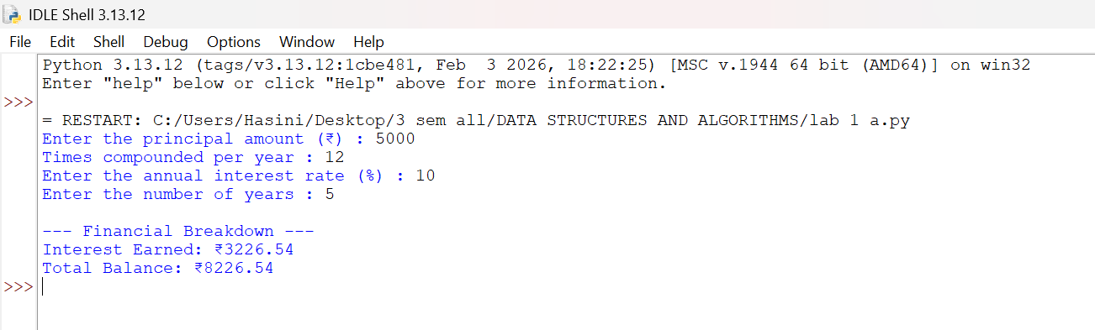

Output(-Ve Case):
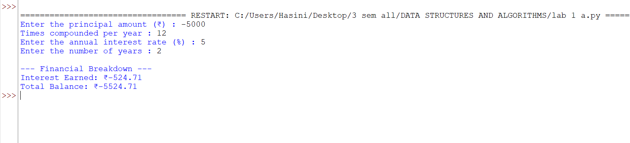

Error Table
S.No. | Error Type | Error / Mistake | Reason | Correction
1 | Syntax Error | Missing : after def C_Int(p,n,r,t) | Function definitions require a colon. | Write def C_Int(p,n,r,t):
2 | Name Error | Using P instead of p | Python is case-sensitive. | Use the same variable name p throughout.
3 | ZeroDivisionError | Entering n = 0 | Division by zero is not allowed. | Enter a positive integer for n.
4 | Value Error | Entering text instead of a number | int() or float() cannot convert invalid text into a number. | Enter valid numeric values.
5 | Logical Error | Using r directly without dividing by 100 | The interest rate is entered as a percentage. | Use decimal_rate = r / 100.
6 | Logical Error | Incorrect exponent in the compound interest formula | The exponent must account for compounding frequency and time. | Use (n * t) in the exponent.
7 | Type Error | Passing a string instead of a number to the function | Arithmetic operations require compatible numeric values. | Convert inputs using int() or float().

Explanation
The function C_Int(p, n, r, t) calculates compound interest.
p represents the principal amount, n the compounding frequency, r the annual interest rate, and t the time in years.
The annual percentage rate is converted to a decimal using r / 100.
The compound interest formula calculates the total amount after t years.
Interest earned is calculated by subtracting the principal from the total amount.
The program displays the interest earned and final balance to two decimal places.

C.) Aim: HR Department stores Employee Id’s in a list develop a recursive program in python to search for a given employee Id in the list.
Program:
def rec_bin_search(arr,key,low,high):
if low > high :
return -1
mid = (low+high)//2
if arr[mid] == key:
return mid
elif key < arr[mid]:
return rec_bin_search(arr,key,low,mid-1)
else:
return rec_bin_search(arr,key,mid+1,high)
Emp_Ids = [1002, 1005, 1012, 1025, 1040, 1077, 1100]
search_id = int(input("Enter Employee ID to search: "))
result_index = rec_bin_search(Emp_Ids,search_id,0,(len(Emp_Ids)-1))
if result_index != -1:
print(f"Employee ID {search_id} found at index {result_index}.")
else:
print(f"Employee ID {search_id} not found in the HR system.")
Output(+Ve Case):
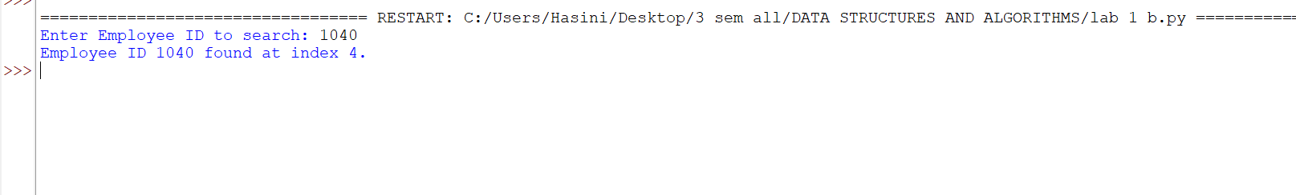
Output(-Ve Case):
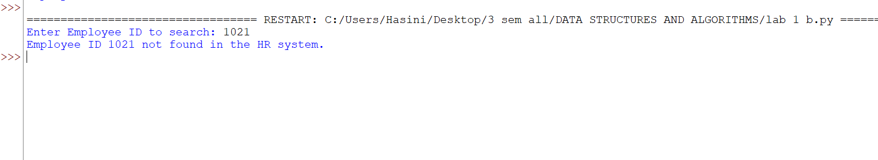

Error Table:
S.No. | Error Type | Error / Mistake | Reason | Correction
1 | Syntax Error | Missing : after def rec_bin_search(arr,key,low,high) | Function definition requires a colon. | Add : at the end.
2 | Indentation Error | Incorrect indentation inside the function | Python requires proper indentation for code blocks. | Indent statements consistently.
3 | Logical Error | Searching an unsorted list | Binary search works only on a sorted list. | Sort Emp_Ids in ascending order.
4 | Logical Error | Incorrect calculation of mid | An incorrect middle index may produce wrong results. | Use mid = (low + high) // 2.
5 | Logical Error | Incorrect recursive call for the left half | The search range may not decrease correctly. | Use rec_bin_search(arr, key, low, mid - 1).
6 | Logical Error | Incorrect recursive call for the right half | The search may skip elements or repeat indefinitely. | Use rec_bin_search(arr, key, mid + 1, high).

Explanation
The function rec_bin_search() searches for an employee ID using recursion.
low and high define the current search range.
The middle index is calculated using (low + high) // 2.
If the middle element matches the key, its index is returned.
If the key is smaller or larger, the function recursively searches the appropriate half.
The program displays the index when found or a not-found message otherwise.

D.) Aim: Develop a python program to print 1st n terms of Fibonacci series.
Program:
def fib(n):
if(n < 0):
print("Please enter a +ve number")
return None
if (n == 0 or n == 1):
return n
else:
return fib(n-1)+fib(n-2)

n = int(input("Enter the number : "))
for i in range (n+1):
print(f"{fib(i)}",end = " ")
Output(+Ve Case):

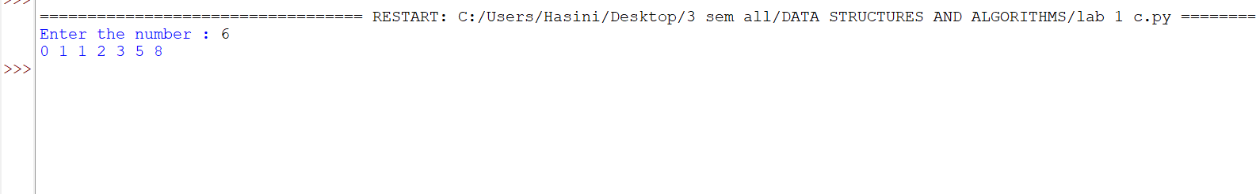

Output(-Ve Case):

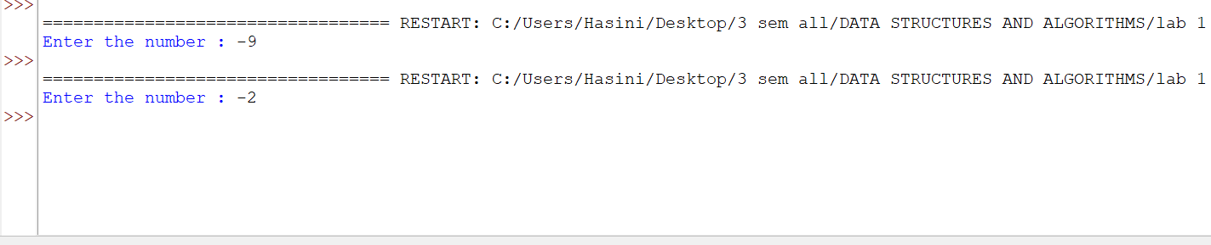

Error Table:
S.No. | Error Type | Error / Mistake | Reason | Correction
1 | Syntax Error | Missing : after def fib(n) | Function definitions require a colon. | Write def fib(n):
2 | Indentation Error | print() inside the for loop is not indented | Python requires indentation inside loops. | Indent print() inside the loop.
3 | Value Error | Entering letters instead of a number | int() cannot convert non-numeric text into an integer. | Enter a valid integer.
4 | Logical Error | Entering a negative number | Fibonacci series is intended here for non-negative integers. | Enter 0 or a positive integer.
5 | Performance Error | Repeated recursive calls to calculate Fibonacci numbers | The same values are calculated multiple times, making the program slow for large inputs. | Use memoization or an iterative approach for better performance.
6 | Logical Error | Using range(n) instead of range(n+1) | The Fibonacci number at index n would not be printed. | Use range(n+1) to print terms from F(0) to F(n).

Explanation
The function fib(n) returns the Fibonacci number at position n.
If n is negative, the function displays a warning and returns None.
The base cases return n when n is 0 or 1.
For other values, recursion adds fib(n-1) and fib(n-2).
The for loop runs from 0 through n.
Each Fibonacci value is printed on the same line.

E.) Aim: Develop a python program to calculate factorial of a given number.
Program:
def fac (n):
if n < 0 :
print("Please aenter a +ve number")
return None
if n == 0 or n == 1:
return 1
else:
return n*fac(n-1)
n = int(input("Enter a number : "))
print(f"The Factorial of {n} is {fac(n)}")
Output(+Ve Case):
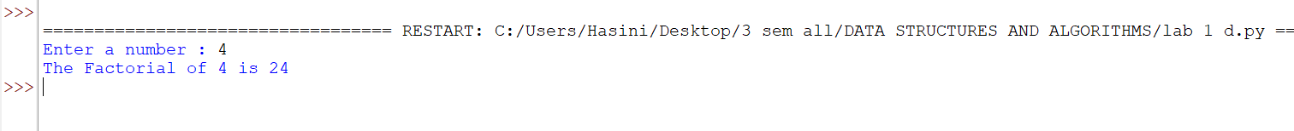
Output(-Ve Case):
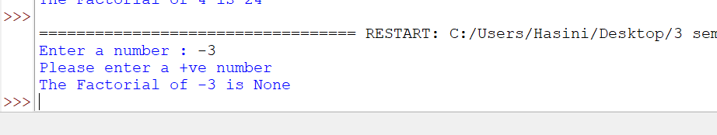

Error Table
S.No. | Error Type | Error | Correction
1 | Spelling Error | "Please aenter a +ve number" | Change aenter to enter.
2 | Value Error | Entering letters instead of a number | Enter a valid integer.
3 | Logical Error | Entering a negative number | Enter a non-negative integer.

Explanation
The function fac(n) calculates the factorial using recursion.
If n is negative, the program displays a warning and returns None.
The base cases return 1 when n is 0 or 1.
For other values, the function returns n multiplied by fac(n-1).
The user enters the number whose factorial is required.
The final factorial value is displayed.

LAB-2:
1.)Applying Searching Algorithms :
A.) Aim: Write a python program to implement linear search.
Program:
def lin_search(arr, key):
for i in range(len(arr)):
if arr[i] == key:
print(f"{key} at index {i}")
return
print(f"{key} not found")
n = int(input("Enter the number of elements: "))
arr = []
print("Enter elements:")
for i in range(n):
arr.append(int(input()))

key = int(input("Enter the key: "))
result = lin_search(arr, key)

Output(+Ve Case):

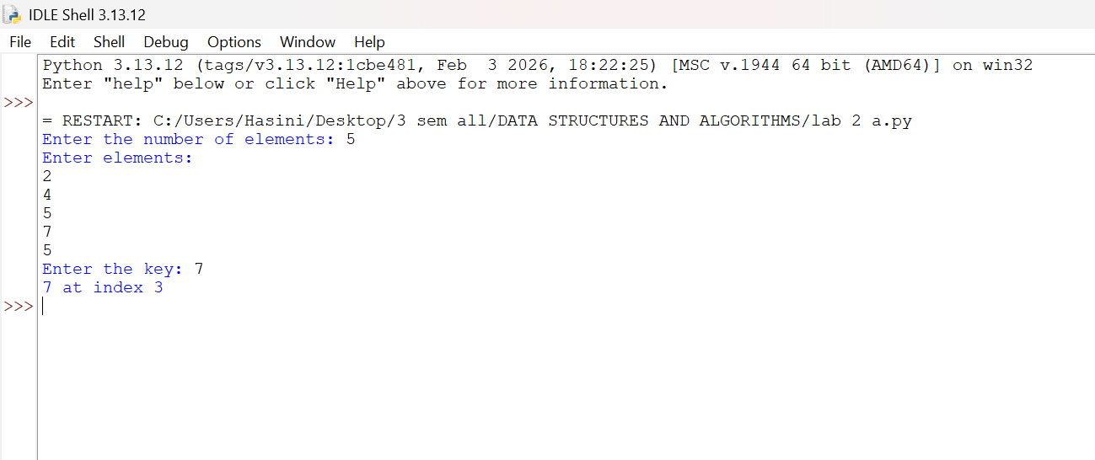

Output(-Ve Case):

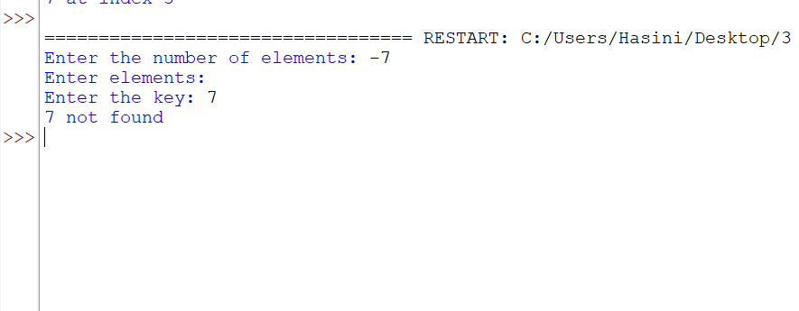

1. Error Table
S.No. | Error Type | Error | Correction
1 | Value Error | Entering letters instead of numbers | Enter valid integers.
2 | Logical Error | Entering a negative number for n | Enter a non-negative number of elements.
3 | Minor Error | Storing the function result in result when the function returns no value | Use lin_search(arr, key) directly or return an index from the function.

Explanation
- Function: lin_search(arr, key) searches for the given key in the array.
- Loop: for i in range(len(arr)) checks each element one by one.
- Condition: if arr[i] == key checks whether the current element matches the key.
- Found: If the key is found, its index is printed and the function stops using return.
- Not Found: If no element matches, the program prints "not found".
- Input: The user enters the number of elements, the array elements, and the key to search.

B.) Aim: Write a python program to implement binary search with sorted array as input.
Program:
def bin_search(arr,key):
low = 0
high = len(arr) - 1
while low <= high:
mid = (high+low)//2
if arr[mid] == key:
return mid
elif arr[mid] < key:
low = mid+1
else:
high = mid-1
return -1
n = int(input("Enter the number of elements: "))
arr = []
print("Enter elements:")
for i in range(n):
arr.append(int(input()))
key = int(input("Enter the key: "))
result = bin_search(arr, key)
if result!=-1:
print(f"Element found at index {result}")
else: print("Element not found")
Output(+Ve Case): 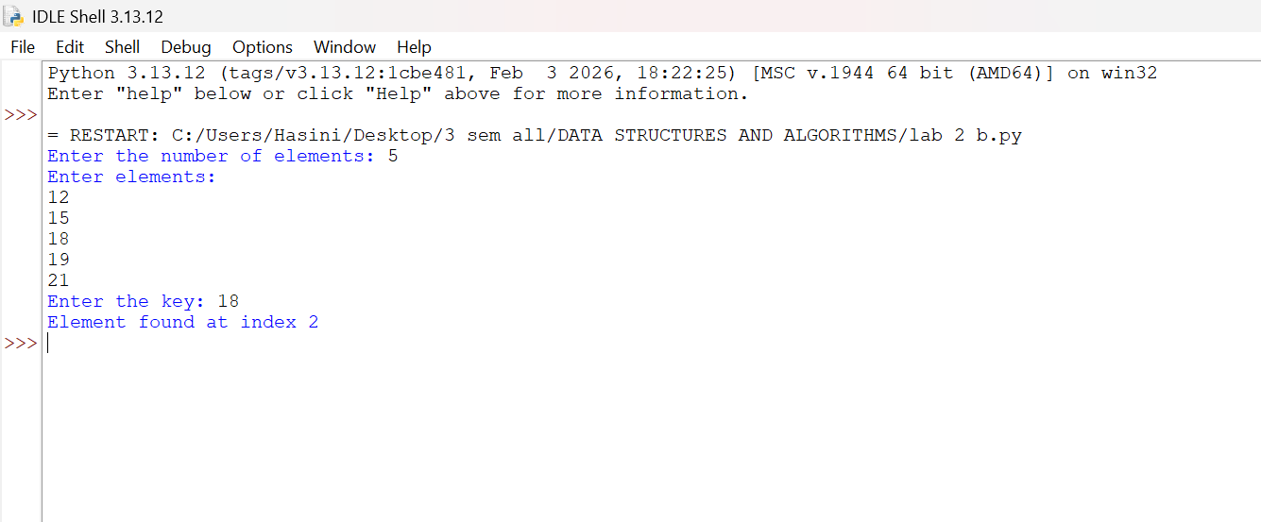
Output(-Ve Case):
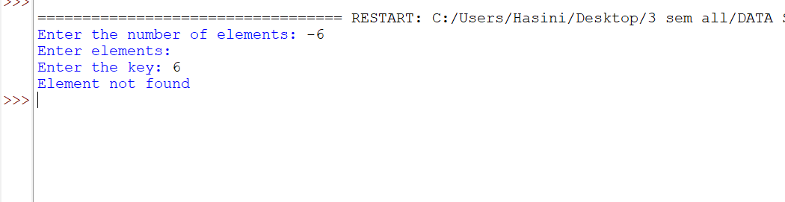

1. Error Table
S.No. | Error Type | Error | Correction
1 | Major Error | Entering an unsorted array | Arrange elements in ascending order before searching.
2 | Value Error | Entering letters instead of numbers | Enter valid integers.
3 | Logical Error | Incorrectly updating low or high | Use low = mid + 1 or high = mid - 1.

Explanation:
- Function: bin_search(arr, key) searches for an element using binary search.
- Initialization: low = 0 and high = len(arr) - 1 define the search range.
- Middle Index: mid = (high + low) // 2 calculates the middle index.
- Comparison: If arr[mid] == key, the function returns the index.
- Search Range: If the key is larger, search the right half; otherwise, search the left half.
- Result: The program prints the element's index if found; otherwise, it prints "Element not found".
(C) Aim: Write a python program to implement binary search with unsorted array as input.
Program:
def bin_search(arr,key):
low = 0
high = len(arr) - 1
while low <= high:
mid = (high+low)//2
if arr[mid] == key:
return mid
elif arr[mid] < key:
low = mid+1
else:
high = mid-1
return -1
n = int(input("Enter the number of elements: "))
arr = []
print("Enter elements:")
for i in range(n):
arr.append(int(input()))
if arr == sorted(arr):
print("\n input list is already sorted")
else:
print("input list is not sorted")
print("sorting list....")
arr.sort()
print(f"Sorted List : {arr}")
key = int(input("Enter the key: "))
result = bin_search(arr, key)
if result!=-1:
print(f"Element found at index {result}")
else:
print("Element not found")
Output
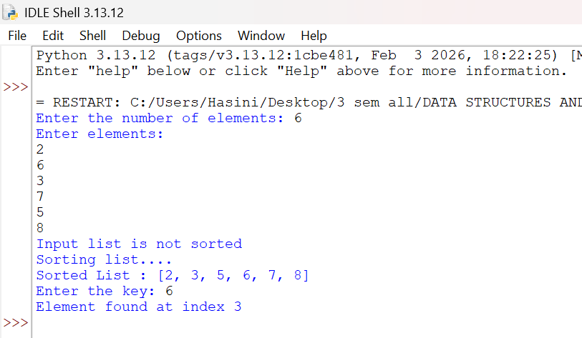

1. Error Table
S.No. | Error Type | Error | Correction
1 | Indentation Error | Incorrect indentation of low = 0 | Align it properly inside the function.
2 | Major Error | Performing binary search on an unsorted list | Sort the list before searching.
3 | Value Error | Entering letters instead of numbers | Enter valid integers.
Explanation
- Function: bin_search(arr, key) searches for an element using binary search.
- Initialization: low and high define the starting and ending indices.
- Sorting Check: arr == sorted(arr) checks whether the input list is already sorted.
- Sorting: If the list is unsorted, arr.sort() arranges elements in ascending order.
- Searching: The function compares the key with the middle element and narrows the search range.
LAB-3:
A.) Aim: Write a python program to apply bubble sort where input elements are taken from the user .
Program:
def bubble_sort(arr):
n = len(arr)
for i in range(n-1):
for j in range(n-i-1):
if arr[j] > arr[j+1]:
arr[j],arr[j+1] = arr[j+1],arr[j]
return arr
n = int(input("Enter the number of elements: "))
arr = []
print("Enter elements:")
for i in range(n):
arr.append(int(input()))
result = bubble_sort(arr)
print(f"Sorted array : {result}")
Output
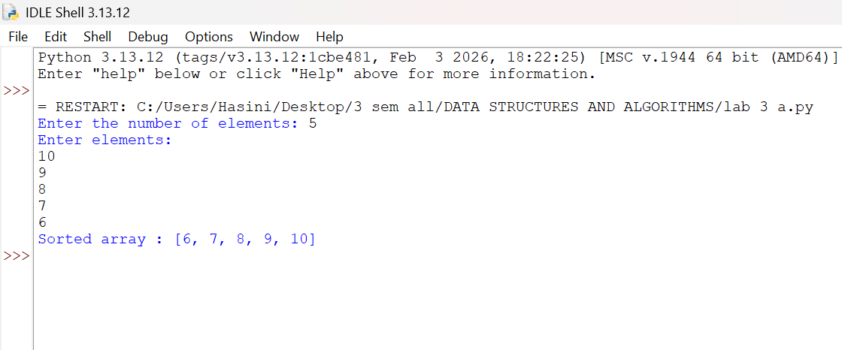

ERROR TABLE:

S.No. | Error Type | Error | Correction
1 | Value Error | Entering non-numeric input | Enter valid integers.
2 | Logical Error | Using incorrect loop limits | Use range(n-1) and range(n-i-1).

Explanation
- Function: bubble_sort(arr) sorts the array.
- Length: n = len(arr) calculates the number of elements.
- Outer Loop: Repeats passes through the array.
- Inner Loop: Compares adjacent elements.
- Swapping: Exchanges elements when they are in the wrong order.
- Output: Displays the sorted array in ascending order.

B.) Aim: Write a python program to apply insertion sort where input elements are taken from the user .
Program:
def insertion_sort(arr):
n = len(arr)
for i in range(1,n):
key = arr[i]
j = i-1
while j >= 0 and arr[j] > key:
arr[j+1] = arr[j]
j = j-1
arr[j+1] = key
return arr
n = int(input("Enter the number of elements: "))
arr = []
print("Enter elements:")
for i in range(n):
arr.append(int(input()))
result = insertion_sort(arr)
print(f"Sorted array : {result}")
Output
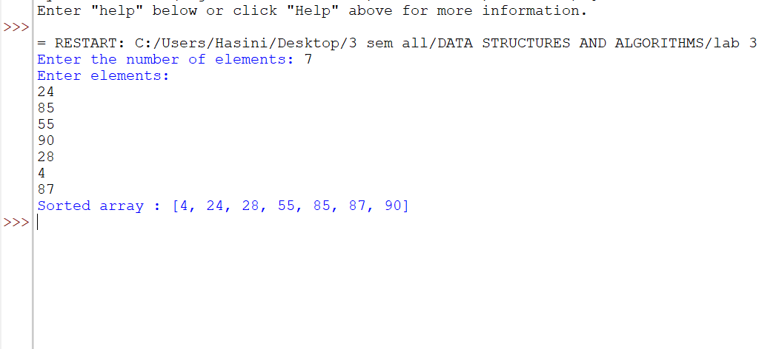

Error Table
S.No. | Error Type | Error | Correction
1 | Value Error | Entering non-numeric input | Enter valid integers.
2 | Logical Error | Incorrectly updating j or shifting elements | Use j = j - 1 and arr[j+1] = key.

Explanation
• Function: insertion_sort(arr) sorts the array.
• Key: Stores the current element to be inserted.
• Comparison: Compares the key with previous elements.
• Shifting: Moves larger elements one position to the right.
• Insertion: Places the key in its correct position.
• Output: Displays the sorted array in ascending order.

C.) Aim: Write a python program to apply selection sort where input elements are taken from the user .
Program:
def selection_sort(arr):
n = len(arr)
for i in range(n-1):
min_index = i
for j in range (i+1,n):
if arr[j] < arr[min_index]:
min_index = j
arr[i],arr[min_index] = arr[min_index],arr[i]
return arr
n = int(input("Enter the number of elements: "))
arr = []
print("Enter elements:")
for i in range(n):
arr.append(int(input()))
result = selection_sort(arr)
print(f"Sorted array : {result}")

Output:
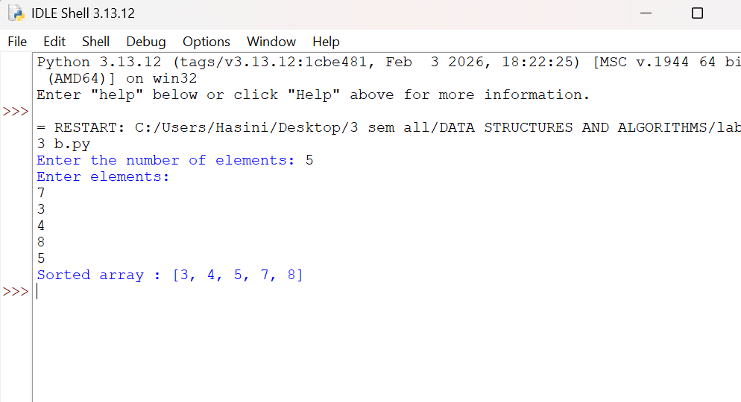

1. Error Table
S.No. | Error Type | Error / Mistake | Correction
1 | Value Error | Entering non-numeric elements | Enter valid integers.
2 | Logical Error | Selecting the wrong minimum element or swap index | Track the minimum index and swap it with arr[i].

Explanation
The selection sort function arranges elements in ascending order.
The outer loop selects the position to fill next.
The inner loop searches the unsorted part of the list for the minimum element.
The index of the smallest element is stored.
The smallest element is swapped with the element at the current position.
The sorted list is displayed after all passes are completed.

LAB-4:
A.) Aim: write a python program to implement quick sort, where the elements are taken from user.
Program:
def quicksort(a,low,high):
if low < high:
i = low
j = high
pivot = low
while i < j:
while i < len(a) and a[i] <= a[pivot]:
i+=1
while a[j] > a[pivot]:
j-=1
if i < j:
a[i],a[j] = a[j],a[i]
a[j],a[pivot] = a[pivot],a[j]
quicksort(a,low,j-1)#Left Part
quicksort(a,j+1,high)#Right Part

#Entering the Elements
n = int(input("Enter the number of elements: "))
a = []
print("Enter elements:")
for i in range(n):
a.append(int(input()))
quicksort(a, 0, n - 1)
print("Sorted Array :.......")
print(a)

Output:
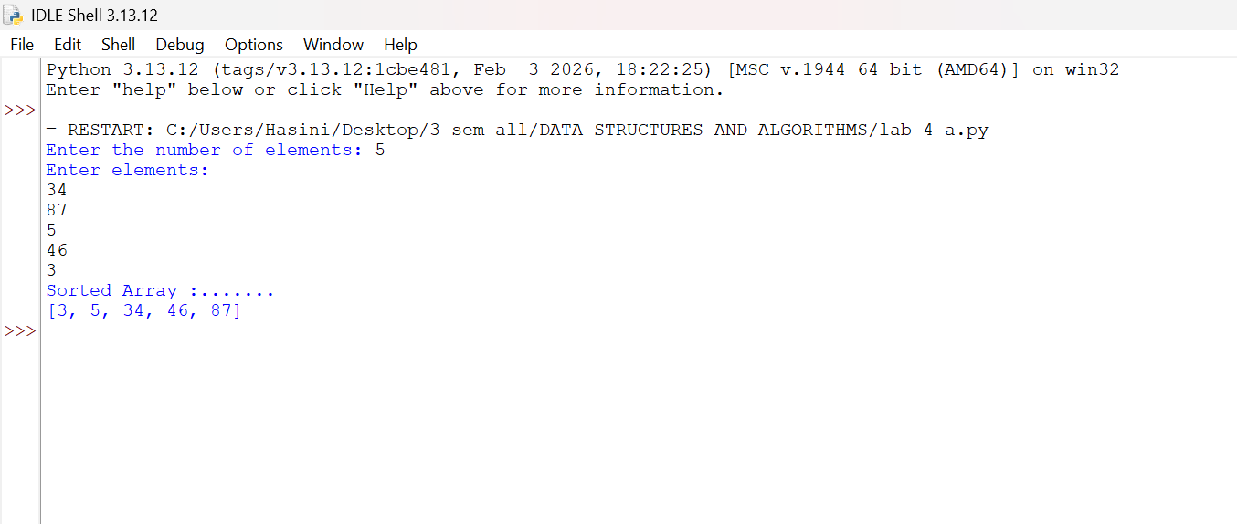

1. Error Table
S.No. | Error Type | Error / Mistake | Correction
1 | Value Error | Entering non-numeric elements | Enter valid integers.
2 | Logical Error | Incorrect pivot partitioning | Check the partition conditions and recursive ranges.

Explanation
Quick sort sorts the list using a divide-and-conquer approach.
A pivot element is selected from the list.
The partition step places smaller elements before the pivot and larger elements after it.
The left and right partitions are sorted recursively.
Recursion stops when a partition has zero or one element.
The program displays the sorted list.

B.) Aim: write a python program to implement merge sort, where the elements are taken from user.
Program:
def merge_sort(arr):
# Base Condition
if len(arr) <= 1:
return arr
# Divide Array
mid = len(arr) // 2
left = arr[:mid]
right = arr[mid:]
# Recursive calls
merge_sort(left)
merge_sort(right)
# Merge sorted halves
i = j = k = 0
while i < len(left) and j < len(right):
if left[i] <= right[j]:
arr[k] = left[i]
i += 1
else:
arr[k] = right[j]
j += 1
k += 1
# Copy remaining elements from Left Array
while i < len(left):
arr[k] = left[i]
i += 1
k += 1
# Copy remaining elements from Right Array
while j < len(right):
arr[k] = right[j]
j += 1
k += 1
return arr
n = int(input("Enter the number of elements: "))
arr = []
print("Enter elements:")
for i in range(n):
arr.append(int(input()))
print("Sorted Array :.......")
print(merge_sort(arr))
Output:
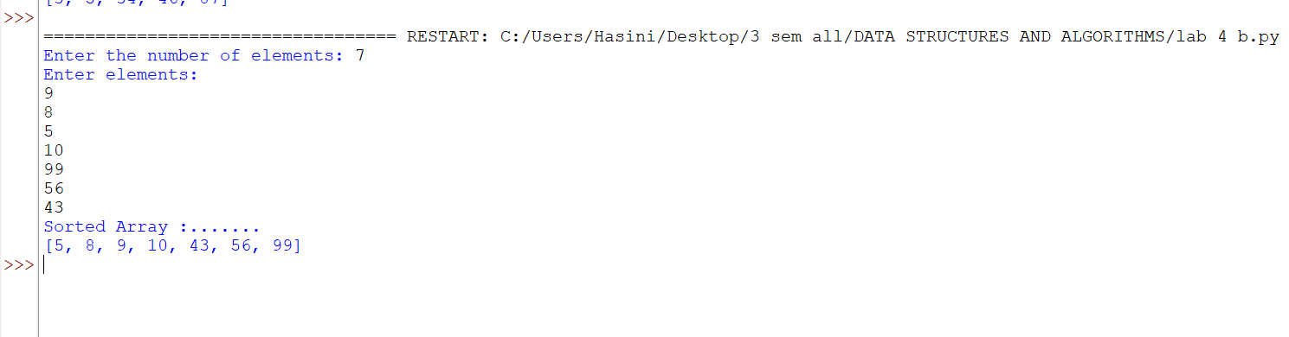

1. Error Table
S.No. | Error Type | Error / Mistake | Correction
1 | Value Error | Entering non-numeric elements | Enter valid integers.
2 | Logical Error | Incorrectly merging the two sorted halves | Compare the front elements of both halves and append remaining elements.
Explanation:
Merge sort uses a divide-and-conquer strategy.
The list is divided into two halves.
Each half is sorted recursively.
The merge step compares elements from the two sorted halves.
The remaining elements from either half are appended.
The merged list is returned in sorted order.

LAB-5:
Aim: A) Write a python program to implement a circular linked list with the below operations: A.create linked list B.insert at beginning C.Insert at end D.Insert at index E.Delete by value F.Delete first node G.Delete last node H.Count number of nodes I.Display/traverse J.exit

Program:
class Node:
#[cite: 12]
def __init__(self, data):
self.data = data
self.next = None
class CircularLinkedList:
#[cite: 12]
def __init__(self):
self.head = None
self.tail = None
# Insert at Beginning[cite: 13]
def insert_begin(self, data):
new = Node(data)
# Case 1: Empty list
if self.head is None:
self.head = new
self.tail = new
new.next = self.head
# Case 2: Non-empty list
else:
new.next = self.head
self.head = new
self.tail.next = self.head
# Insert at End[cite: 14]
def insert_end(self, data):
new = Node(data)
# Case 1: Empty list
if self.head is None:
self.head = new
self.tail = new
new.next = self.head
# Case 2: Non-empty list
else:
new.next = self.head
self.tail.next = new
self.tail = new
# Insert at Particular Position[cite: 15]
# Position starts from 0
def insert_position(self, position, data):
# Insert at beginning
if position == 0:
self.insert_begin(data)
return
if self.head is None or position < 0:
print("Invalid position")
return
new = Node(data)
temp = self.head
# Move to the node before the required position[cite: 16]
for i in range(position - 1):
temp = temp.next
# We have completed one circle
if temp == self.head:
print("Invalid position")
return
# Insert new node
new.next = temp.next
temp.next = new
# If inserted after tail, update tail
if temp == self.tail:
self.tail = new
# Delete at Beginning[cite: 17]
def delete_begin(self):
if self.head is None:
print("List is empty")
return
# Only one node
if self.head == self.tail:
self.head = None
self.tail = None
# More than one node
else:
self.head = self.head.next
self.tail.next = self.head
# Delete at End[cite: 18]
def delete_end(self):
if self.head is None:
print("List is empty")
return
# Only one node
if self.head == self.tail:
self.head = None
self.tail = None
return
# Find node before tail
temp = self.head
while temp.next != self.tail:
temp = temp.next
temp.next = self.head
self.tail = temp
# Traverse the Circular Linked List[cite: 19]
def traverse(self):
if self.head is None:
print("List is empty")
return
temp = self.head
while True:
print(temp.data, end=" -> ")
temp = temp.next
if temp == self.head:
break
print("(back to head)")

# Display Head and Tail[cite: 20]
def display_head_tail(self):
if self.head is None:
print("List is empty")
else:
print("Head =", self.head.data)
print("Tail =", self.tail.data)
print("Tail.next =", self.tail.next.data)
# Menu-driven implementation
if __name__ == "__main__":
cll = CircularLinkedList()
while True:
print("\n--- Circular Linked List Menu ---")
print("1. Insert at Beginning")
print("2. Insert at End")
print("3. Insert at Position")
print("4. Delete at Beginning")
print("5. Delete at End")
print("6. Traverse List")
print("7. Display Head and Tail")
print("8. Exit")
ch = int(input("Enter your choice: "))
if ch == 1:
x = int(input("Value: "))
cll.insert_begin(x)
elif ch == 2:
x = int(input("Value: "))
cll.insert_end(x)
elif ch == 3:
pos = int(input("Position (starts from 0): "))
x = int(input("Value: "))
cll.insert_position(pos, x)
elif ch == 4:
cll.delete_begin()
elif ch == 5:
cll.delete_end()
elif ch == 6:
cll.traverse()
elif ch == 7:
cll.display_head_tail()
elif ch == 8:
print("Exiting...")
break
else:
print("Invalid choice, please try again." )

Output:
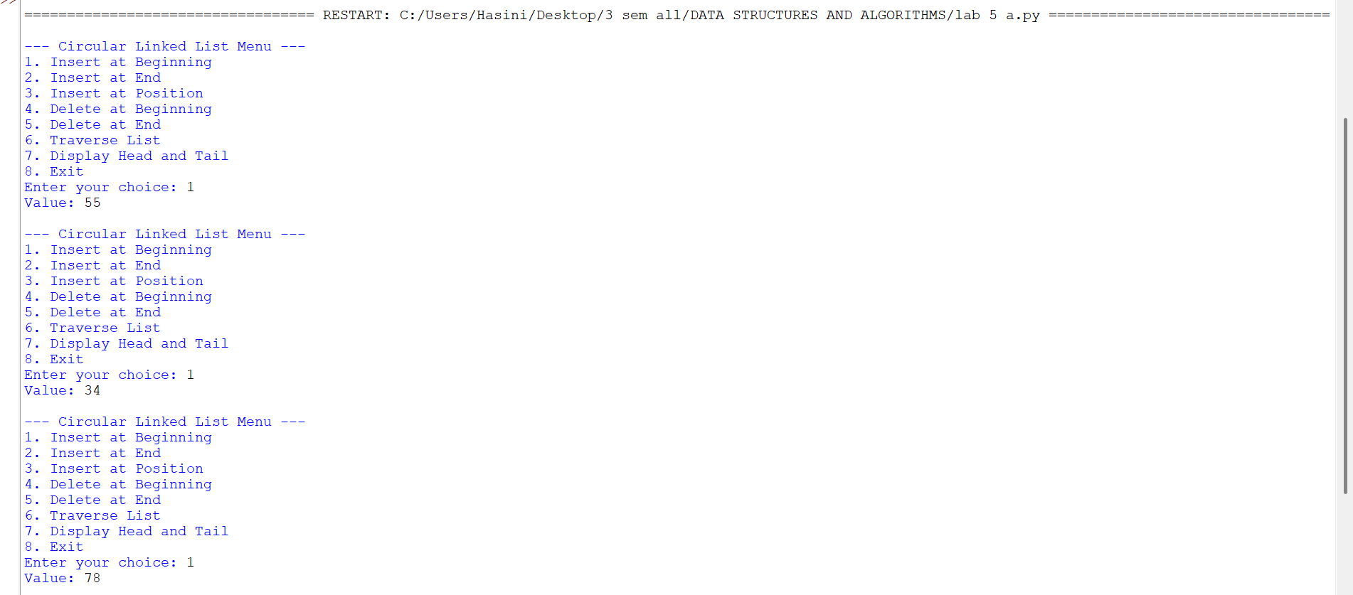

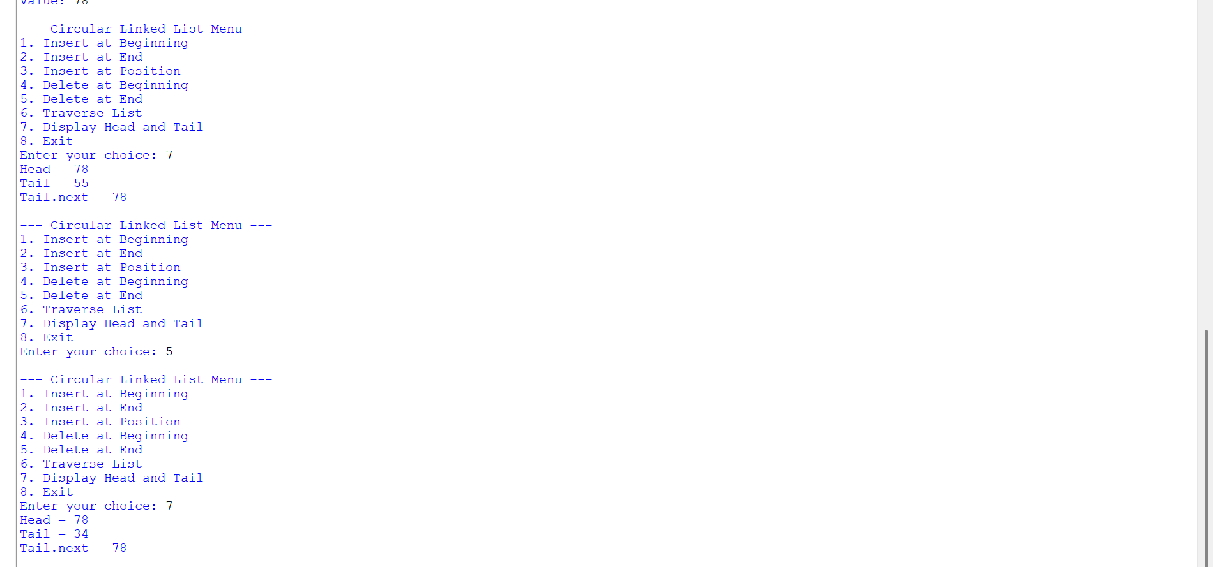

1. Error Table
S.No. | Error Type | Error / Mistake | Correction
1 | Logical Error | Failing to link the last node back to the first node | Set the last node’s next reference to the head.
2 | Runtime Error | Inserting or deleting from an empty list without checking | Check whether the list is empty before the operation.
3 | Logical Error | Using an incorrect index or value during insertion/deletion | Validate the index/value and update links carefully.

Explanation
A circular linked list stores data in nodes connected by next references.
The last node links back to the first node instead of pointing to None.
Insertion at the beginning or end requires updating node links and possibly the head.
Insertion at an index requires locating the correct previous node.
Deletion operations update links to bypass the removed node.
Display or traversal must stop when it reaches the starting node again.

B.) Aim: Write a python program to implement a single linked list with the below operations: A.create linked list B.insert at beginning C.Insert at end D.Insert at index E.Delete by value F.Delete first node G.Delete last node H.Count number of nodes I.Display/traverse J.exit
Program:
class Node:
def __init__(self, data):
self.data = data
self.next = None
class SinglyLinkedList:
def __init__(self):
self.head = None
def create(self):
n = int(input(("Enter number of elements:")))
for i in range(n):
x = int(input(("Enter value:")))
new = Node(x)
if self.head is None:
self.head = new
else:
temp = self.head
while temp.next:
temp = temp.next
temp.next = new
def insert_begin(self, data):
new = Node(data)
new.next = self.head
self.head = new
def insert_end(self, data):
new = Node(data)
if self.head is None:
self.head = new
else:
temp = self.head
while temp.next:
temp = temp.next
temp.next = new
def insert_index(self, index, data):
if index == 0:
self.insert_begin(data)
return
elif index > self.count() or index < 0:
print("Invalid Index")
return
new = Node(data)
temp = self.head
for i in range(index - 1):
temp = temp.next
new.next = temp.next
temp.next = new
def deleteAtBeg(self):
if self.head is None:
print("No Data to delete")
else:
temp = self.head
self.head = temp.next
print("Deleted Value = ",temp.data)
def deleteAtEnd(self):
if self.head is None:
print("No Data to delete")
elif self.head.next is None:
self.head = None
else:
temp = self.head
temp1 = temp
while temp.next:
temp1 = temp
temp = temp.next
temp1.next = None
def delete(self, value):
if self.head is None:
print("No Data to delete")
else:
temp = self.head
if temp and temp.data == value:
self.head = temp.next
print("Value deleted")
return
while temp.next and temp.next.data != value:
temp = temp.next
if temp.next is None:
print("Value not present")
else:
temp.next = temp.next.next
print("Value deleted")
def display(self):
if self.head is None:
print("No Data")
else:
temp = self.head
while temp:
print(temp.data, end=" -> ")
temp = temp.next
print("None")
def count(self):
if self.head is None:
print("No Linked List")
return 0
else:
c = 0
temp = self.head
while temp:
c += 1
temp = temp.next
print(f"Number of nodes = {c}")
return c
# Menu-driven implementation matching the provided snippet
if __name__ == "__main__":
sll = SinglyLinkedList()
while True:
print("\n1. Create\n2. Insert at Beginning\n3. Insert at End\n4. Insert at Index\n5. Delete Value\n6. Delete at Beginning\n7. Delete at End\n8. Count\n9. Display\n10. Exit")
ch = int(input("Enter choice: "))
if ch == 1:
sll.create()
elif ch == 2:
x = int(input("Value: "))
sll.insert_begin(x)
elif ch == 3:
x = int(input("Value: "))
sll.insert_end(x) elif ch == 4:
idx = int(input("Index: "))
x = int(input("Value: "))
sll.insert_index(idx, x)
elif ch == 5:
x = int(input("Delete value: "))
sll.delete(x)
elif ch == 6:
sll.deleteAtBeg()
elif ch == 7:
sll.deleteAtEnd()
elif ch == 8:
sll.count()
elif ch == 9:
sll.display()
elif ch == 10:
break
Output:

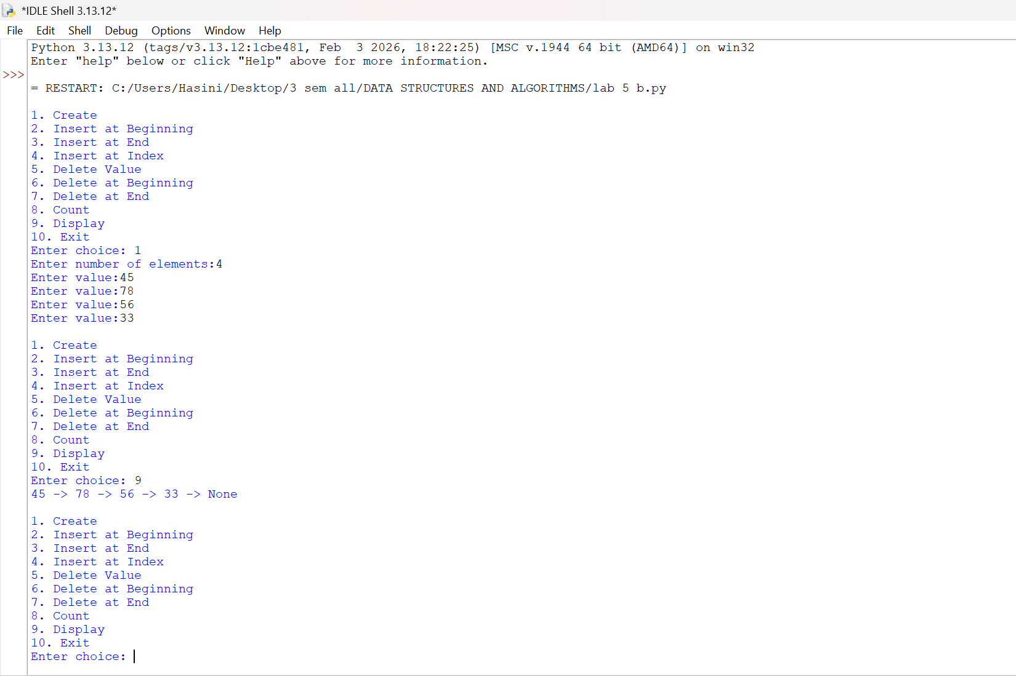

1. Error Table
S.No. | Error Type | Error / Mistake | Correction
1 | Logical Error | Not updating the next reference during insertion | Update the new node and neighbouring node links.
2 | Runtime Error | Deleting or accessing a node in an empty list | Check whether the head is None first.
3 | Logical Error | Incorrectly handling deletion of the first node | Update head to head.next.

Explanation
A singly linked list consists of nodes containing data and a next reference.
The head points to the first node in the list.
Insertion operations create nodes and update the required links.
Deletion operations bypass the node being removed.
Searching and display traverse the list from head until None.
Empty-list checks help prevent invalid operations.

LAB-6:
A ) Aim: Write a python program to implement stack operations such as push, pop, peek, display using linked list.
Program:
class Node:
def __init__(self, data):
self.data = data
self.next = None
class Stack:
def __init__(self):
self.top = None
def push(self, data):
new = Node(data)
new.next = self.top
self.top = new
print(data, "pushed into stack")
def pop(self):
if self.top is None:
print("Stack Underflow")
else:
print(self.top.data, "popped from stack")
self.top = self.top.next
def peek(self):
if self.top is None:
print("Stack is empty")
else:
print("Top element:", self.top.data)
def display(self):
if self.top is None:
print("Stack is empty")
else:
temp = self.top
print("Stack elements:")
while temp is not None:
print(temp.data)
temp = temp.next
s = Stack()
while True:
print("\n--- STACK USING LINKED LIST ---")
print("1. Push")
print("2. Pop")
print("3. Peek")
print("4. Display")
print("5. Exit")
choice = int(input("Enter your choice: "))
if choice == 1:
data = int(input("Enter the element: "))
s.push(data)
elif choice == 2:
s.pop()
elif choice == 3:
s.peek()
elif choice == 4:
s.display()
elif choice == 5:
print("Program terminated")
break
else:
print("Invalid choice")

Output:
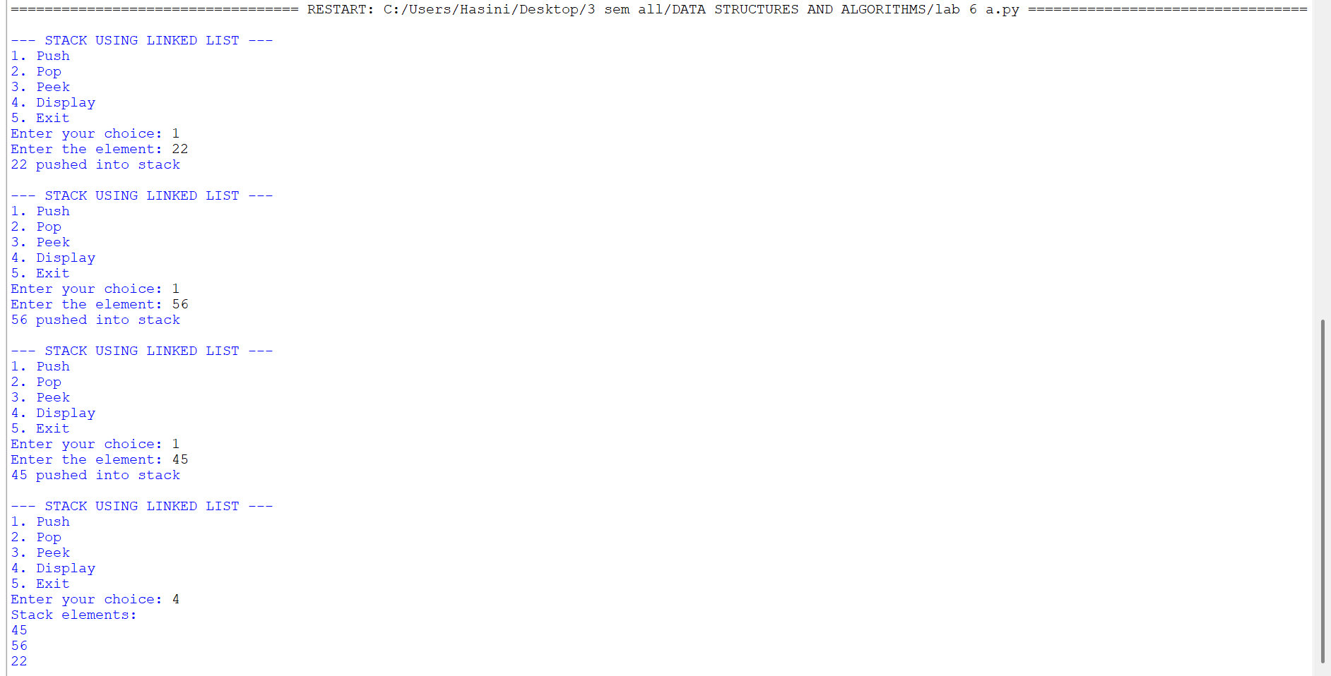

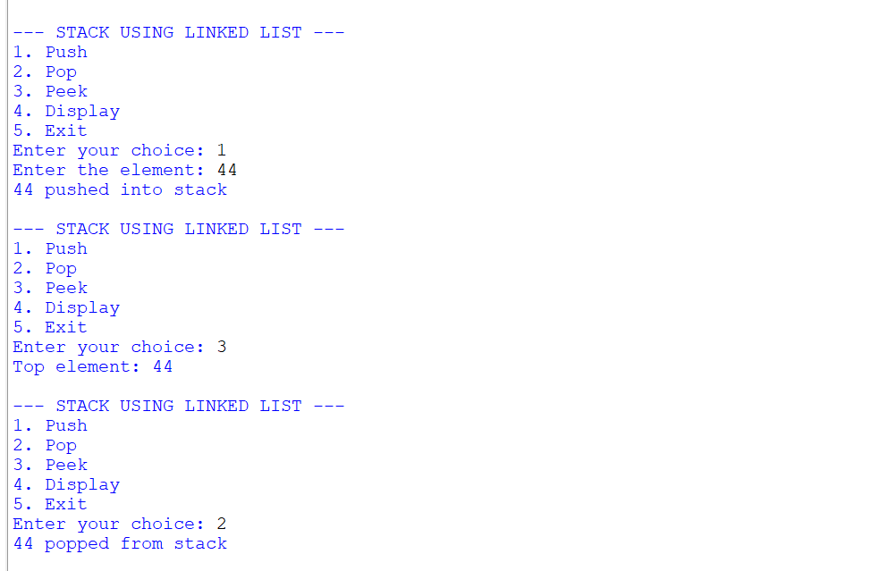

1. Error Table
S.No. | Error Type | Error / Mistake | Correction
1 | Runtime Error | Popping or peeking when the stack is empty | Check for stack underflow before the operation.
2 | Logical Error | Updating the top pointer or array index incorrectly | Update top correctly after push and pop.

Explanation
A stack follows the Last In, First Out (LIFO) principle.
Push adds an element to the top of the stack.
Pop removes and returns the top element.
Peek displays the top element without removing it.
Display shows the elements currently stored in the stack.
Empty-stack checks prevent pop or peek operations when no elements exist.

B ) Aim: Write a python program to implement stack operations such as push, pop, peek, display using an array.
Program:
class StackEx:
#
def __init__(self, size):
self.size = size
self.stack = [None] * size
self.top = -1

# Push operation
def push(self, item):
if self.top == self.size - 1:
print("Stack Overflow")
else:
self.top += 1
self.stack[self.top] = item
print(item, "pushed into the stack")

# Pop operation
def pop(self):
if self.top == -1:
print("Stack Underflow")
else:
item = self.stack[self.top]
self.stack[self.top] = None
self.top -= 1
print(item, "popped from the stack")

# Peek operation
def peek(self):
if self.top == -1:
print("Stack is empty")
else:
print("Top element:", self.stack[self.top])

# Display operation
def display(self):
if self.top == -1:
print("Stack is empty")
else:
print("The elements of the stack are:")
for i in range(self.top, -1, -1):
print(self.stack[i])

# Create stack
size = int(input("Enter the size of the stack: "))
s = StackEx(size)
while True:
print("\n----- STACK MENU USING AN ARRAY-----")
print("1. Push")
print("2. Pop")
print("3. Peek")
print("4. Display")
print("5. Exit")
choice = int(input("Enter your choice: "))
if choice == 1:
item = int(input("Enter the element to push: "))
s.push(item)
elif choice == 2:
s.pop()
elif choice == 3:
s.peek()
elif choice == 4:
s.display()
elif choice == 5:
print("Program terminated.")
break
else:
print("Invalid choice")

Output:
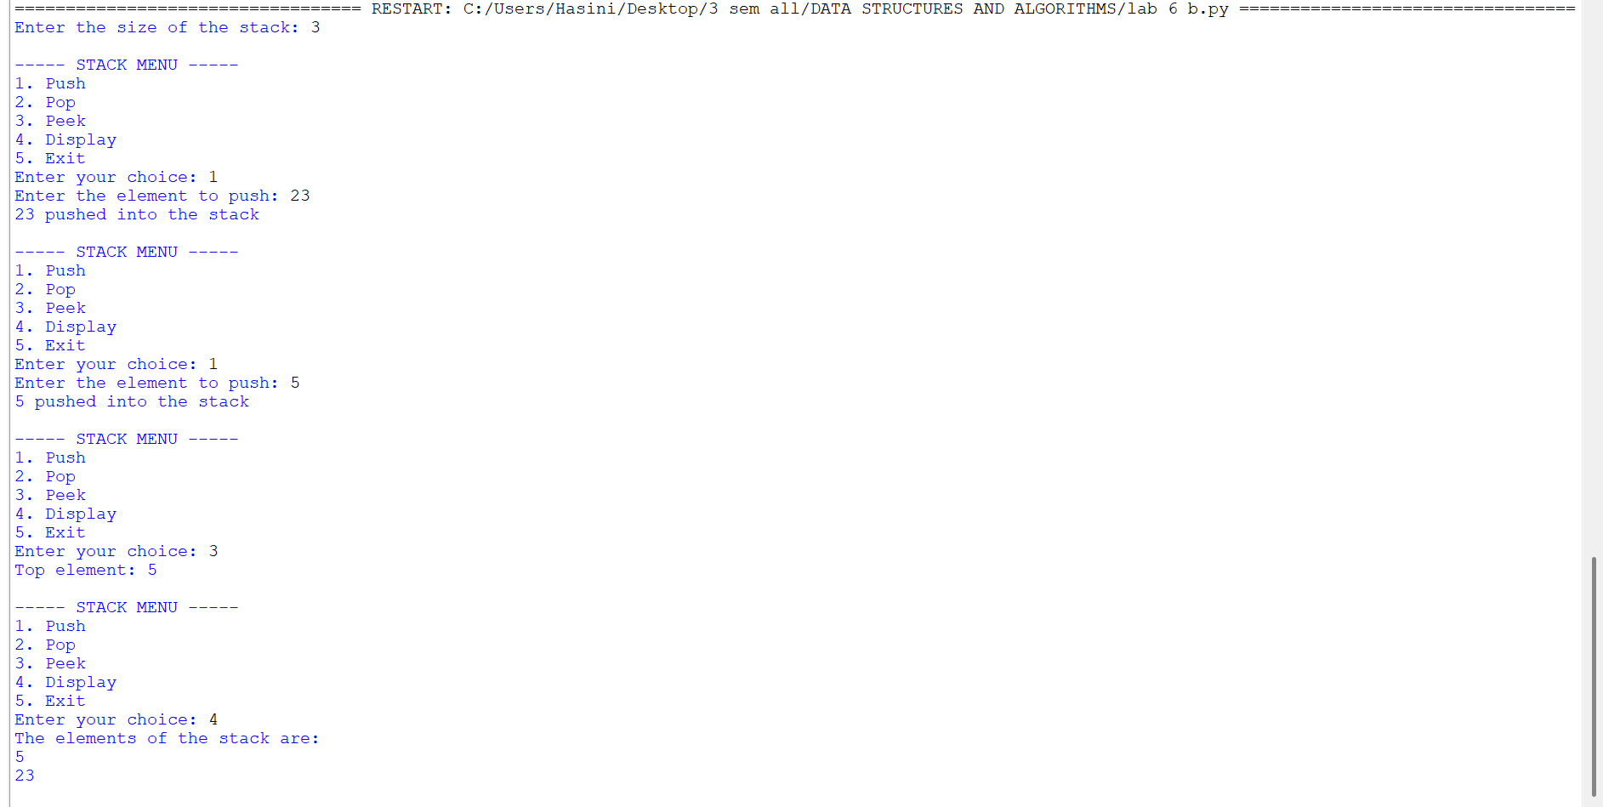

1. Error Table
S.No. | Error Type | Error / Mistake | Correction
1 | Runtime Error | Popping or peeking when the stack is empty | Check for stack underflow before the operation.
2 | Logical Error | Updating the top pointer or array index incorrectly | Update top correctly after push and pop.

Explanation
A stack follows the Last In, First Out (LIFO) principle.
Push adds an element to the top of the stack.
Pop removes and returns the top element.
Peek displays the top element without removing it.
Display shows the elements currently stored in the stack.
Empty-stack checks prevent pop or peek operations when no elements exist.
LAB-7:
A.) Aim: Write a python program to implement queue and its operations such as enqueue, dequeue, peek and display with a menu driven approach using an array
Program:
class Node:
def __init__(self, data):
self.data = data
self.next = None
class QueueEx:
def __init__(self):
self.front = None
self.rear = None
def enqueue(self, x):
new = Node(x)
if self.rear is None:
self.front = self.rear = new
else:
self.rear.next = new
self.rear = new
print(item, "inserted into the queue")
def dequeue(self):
if self.front is None:
print("Queue underflow")
else:
x = self.front.data
self.front = self.front.next
if self.front is None:
self.rear = None
print(f"{x} deleted from the queue")

def peek(self):
if self.front is None:
print("Queue is empty")
else:
print("Front element:", self.front.data)
def display(self):
if self.front is None:
print("Queue is empty")
else:
temp = self.front
print("Queue elements are:")
while temp:
print(temp.data, end=" ")
temp = temp.next
print()
q = QueueEx()
while True:
print("\n----- QUEUE MENU -----")
print("1. Enqueue")
print("2. Dequeue")
print("3. Peek")
print("4. Display")
print("5. Exit")
choice = int(input("Enter your choice: "))
if choice == 1:
item = int(input("Enter the element to enqueue: "))
q.enqueue(item)
elif choice == 2:
q.dequeue()
elif choice == 3:
q.peek()
elif choice == 4:
q.display()
elif choice == 5:
print("Program terminated.")
break
else:
print("Invalid choice")

Output:

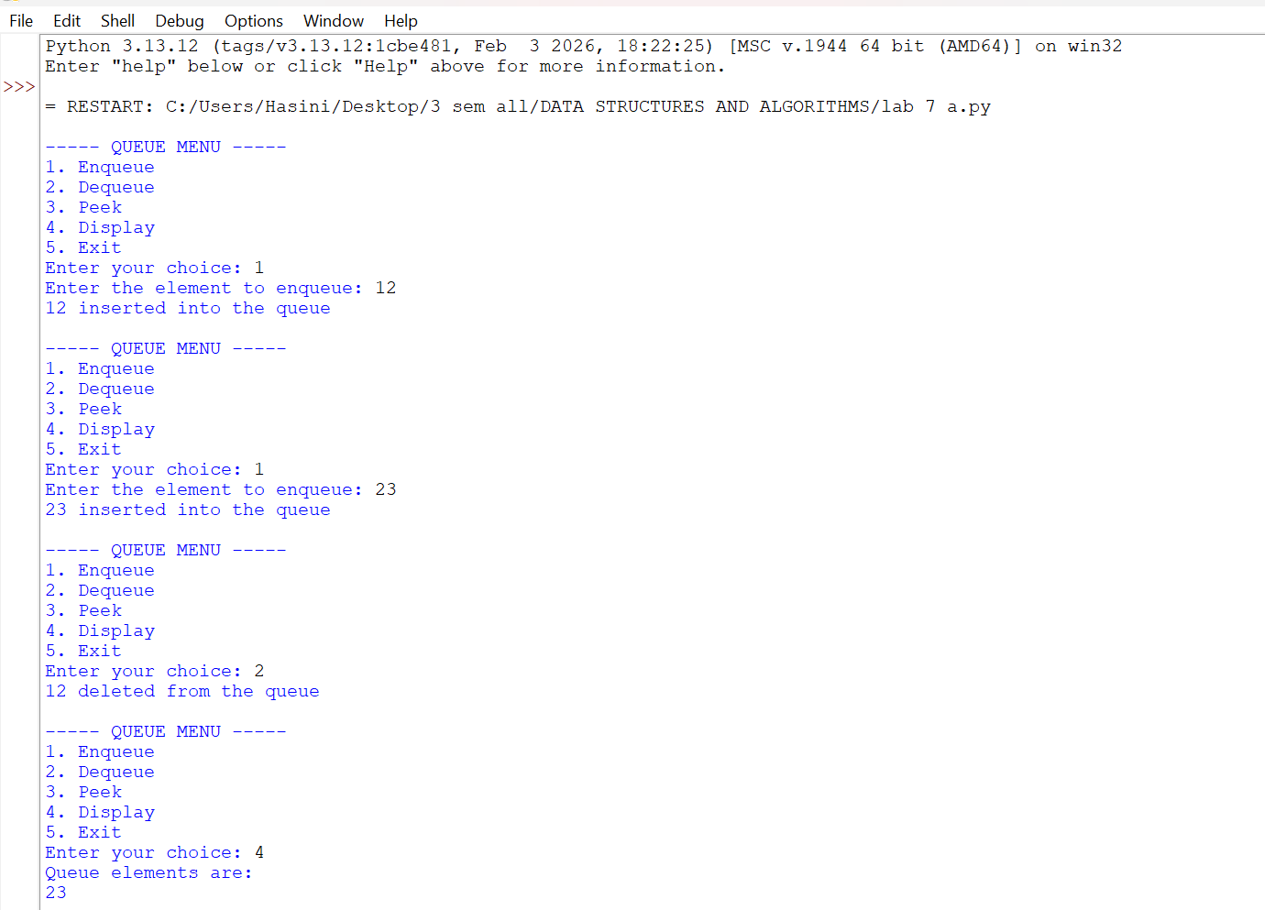

1. Error Table
S.No. | Error Type | Error / Mistake | Correction
1 | Runtime Error | Dequeuing or peeking when the queue is empty | Check whether the queue is empty first.
2 | Logical Error | Updating front or rear incorrectly | Update front and rear according to the queue implementation.
3 | Overflow Error | Enqueuing into a full fixed-size array queue | Check whether the queue is full before enqueueing.

Explanation
A queue follows the First In, First Out (FIFO) principle.
Enqueue adds a new element at the rear.
Dequeue removes the element at the front.
Peek displays the front element without removing it.
Display shows the queue elements in their current order.
Empty and full checks help prevent underflow and overflow.

B.) Aim: Write a python program to implement queue and its operations such as enqueue, dequeue, peek and display with a menu driven approach using an linked list.
Program:
class Node:
def __init__(self, data):
self.data = data
self.next = None
class QueueEx:
def __init__(self):
self.front = None
self.rear = None
# Enqueue operation (Insert at the rear)
def enqueue(self, x):
new_node = Node(x)
# If the queue is empty, both front and rear point to the new node
if self.rear is None:
self.front = self.rear = new_node
else:
self.rear.next = new_node
self.rear = new_node
print(x, "inserted into the queue")
# Dequeue operation (Delete from the front)
def dequeue(self):
if self.front is None:
print("Queue Underflow")
else:
x = self.front.data
self.front = self.front.next
# If the queue becomes empty after deletion, update rear to None
if self.front is None:
self.rear = None
print(f"{x} deleted from the queue"
# Peek operation (View the front element)
def peek(self):
if self.front is None:
print("Queue is empty")
else:
print("Front element:", self.front.data)
# Display operation (Traverse from front to rear)
def display(self):
if self.front is None:
print("Queue is empty")
else:
temp = self.front
print("Queue elements are:")
while temp:
print(temp.data, end=" ")
temp = temp.next
print() # For a new line
# Main Program Loop
q = QueueEx()
while True:
print("\n----- QUEUE USING SL MENU -----")
print("1. Enqueue")
print("2. Dequeue")
print("3. Peek")
print("4. Display")
print("5. Exit")
try:
choice = int(input("Enter your choice: "))
if choice == 1:
item = int(input("Enter the element to enqueue: "))
q.enqueue(item)
elif choice == 2:
q.dequeue()
elif choice == 3:
q.peek()
elif choice == 4:
q.display()
elif choice == 5:
print("Program terminated.")
break
else:
print("Invalid choice. Please choose between 1 and 5.")
except ValueError:
print("Please enter a valid integer number.")
Output:
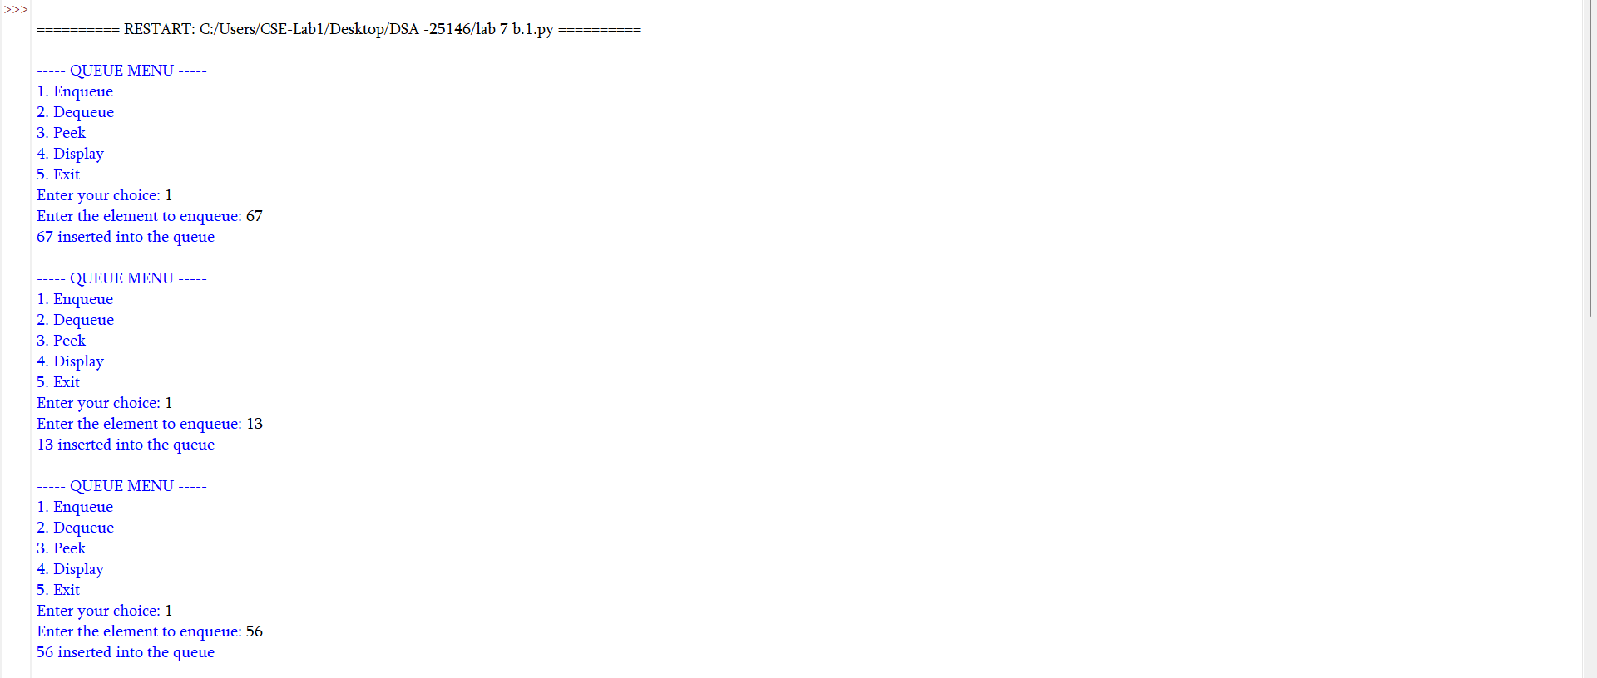
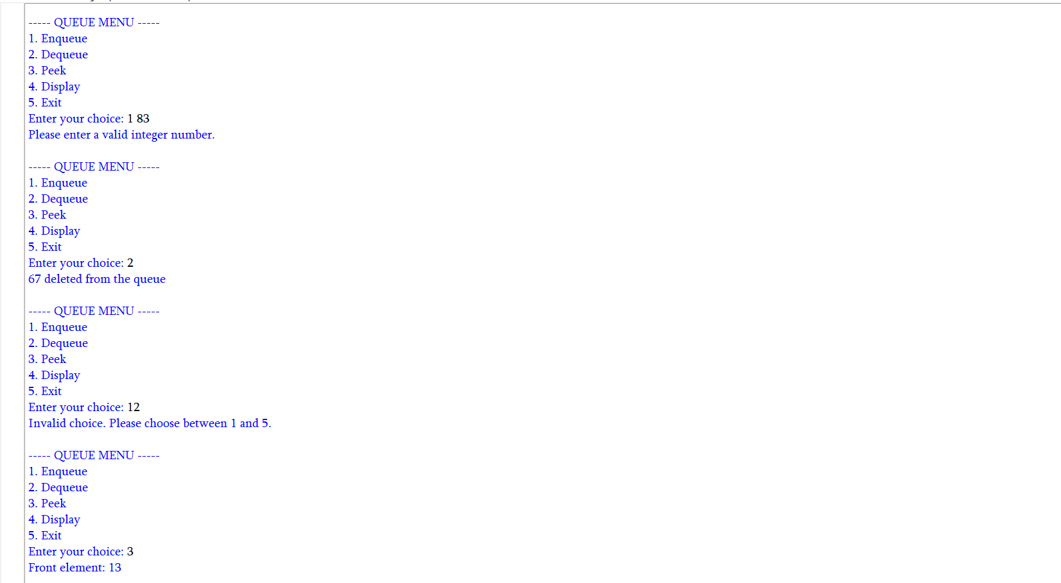

Error Table
S.No. | Error Type | Error / Mistake | Correction
1 | Runtime Error | Dequeuing or peeking when the queue is empty | Check whether the queue is empty first.
2 | Logical Error | Updating front or rear incorrectly | Update front and rear according to the queue implementation.
3 | Overflow Error | Enqueuing into a full fixed-size array queue | Check whether the queue is full before enqueueing.

Explanation
A queue follows the First In, First Out (FIFO) principle.
Enqueue adds a new element at the rear.
Dequeue removes the element at the front.
Peek displays the front element without removing it.
Display shows the queue elements in their current order.
Empty and full checks help prevent underflow and overflow.

C) Aim: Write a python program to implement circular queue and its operations such as enqueue, dequeue, peek and display with a menu driven approach using an array
Program:
class CircularQueueEx:
def __init__(self, size):
self.size = size
self.queue = [None] * size
self.front = -1
self.rear = -1
# Enqueue operation (Insert element)
def enqueue(self, item):
# Condition for Queue Overflow

if (self.rear + 1) % self.size == self.front:
print("Queue Overflow")
else:
# If inserting the first element
if self.front == -1:
self.front = 0
# Circularly increment rear index
self.rear = (self.rear + 1) % self.size
self.queue[self.rear] = item
print(item, "inserted into the circular queue")
# Dequeue operation (Delete element)
def dequeue(self):
# Condition for Queue Underflow
if self.front == -1:
print("Queue Underflow")
else:
item = self.queue[self.front]
self.queue[self.front] = None # Clear the slot

# If the queue has only one element, reset pointers after deletion
if self.front == self.rear:
self.front = -1
self.rear = -1
else:
# Circularly increment front index
self.front = (self.front + 1) % self.size
print(f"{item} deleted from the circular queue")
# Peek operation (View the front element)
def peek(self):
if self.front == -1:
print("Queue is empty")
else:
print("Front element:", self.queue[self.front])
# Display operation
def display(self):
if self.front == -1:
print("Queue is empty")
else:
print("The elements of the circular queue are:")
i = self.front
while True:
print(self.queue[i], end=" ")
if i == self.rear:
break
i = (i + 1) % self.size
print() # For a new line
# Main Program Loop
size = int(input("Enter the size of the circular queue: "))
cq = CircularQueueEx(size)
while True:
print("\n----- CIRCULAR QUEUE USING ARRAY MENU -----")
print("1. Enqueue")
print("2. Dequeue")
print("3. Peek")
print("4. Display")
print("5. Exit")
try:
choice = int(input("Enter your choice: "))
if choice == 1:
item = int(input("Enter the element to enqueue: "))
cq.enqueue(item)
elif choice == 2:
cq.dequeue()
elif choice == 3:
cq.peek()
elif choice == 4:
cq.display()
elif choice == 5:
print("Program terminated.")
break
else:
print("Invalid choice. Please choose between 1 and 5.")
except ValueError:
print("Please enter a valid integer number.

Output:

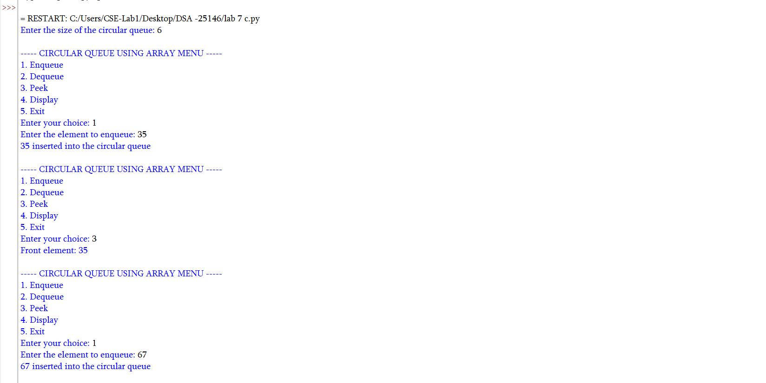
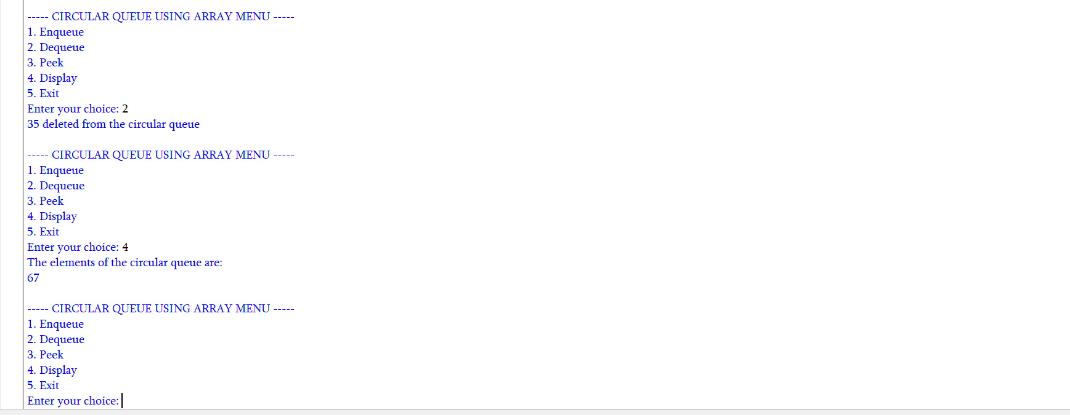

1. Error Table
S.No. | Error Type | Error / Mistake | Correction
1 | Logical Error | Not wrapping front or rear to the beginning of the array | Use modulo arithmetic, such as (rear + 1) % size.
2 | Overflow Error | Adding an element when the circular queue is full | Check the full condition before enqueueing.
3 | Runtime Error | Dequeuing from an empty queue | Check the empty condition first.

Explanation
A circular queue follows the FIFO principle and reuses array positions.
Enqueue inserts an element at the rear.
Dequeue removes an element from the front.
Modulo arithmetic wraps front and rear indices around the array.
Peek displays the front element without removing it
D.) Aim: Write a python program to implement circular queue and its operations such as enqueue, dequeue, peek and display with a menu driven approach using an linked list.
Program:
class Node:
def __init__(self, data):
self.data = data
self.next = None
class CircularQueueLinkedList:
def __init__(self):
self.rear = None
# Enqueue operation (Insert element at the end)
def enqueue(self, item):
new_node = Node(item)
# If the queue is empty
if self.rear is None:
self.rear = new_node
self.rear.next = self.rear # Point to itself to maintain circularity
else:
# New node points to the front node
new_node.next = self.rear.next
# Current rear node points to the new node
self.rear.next = new_node
# Move the rear pointer to the new node
self.rear = new_node
print(item, "inserted into the circular queue")
# Dequeue operation (Delete element from the front)
def dequeue(self):
# Condition for Underflow
if self.rear is None:
print("Queue Underflow")
else:
front = self.rear.next
item = front.data
# If the queue has only one node
if self.rear == front:
self.rear = None
else:
# Rear bypasses the old front to point to the next node
self.rear.next = front.next
print(f"{item} deleted from the circular queue")
# Peek operation (View the front element)
def peek(self):
if self.rear is None:
print("Queue is empty")
else:
front = self.rear.next
print("Front element:", front.data)
# Display operation
def display(self):
if self.rear is None:
print("Queue is empty")
else:
print("The elements of the circular queue are:")
front = self.rear.next
temp = front
while True:
print(temp.data, end=" ")
temp = temp.next
# Stop when we loop back to the front node
if temp == front:
break
print() # For a new line
# Main Program Loop
cq = CircularQueueLinkedList()
while True:
print("\n----- CIRCULAR QUEUE (LINKED LIST) MENU -----")
print("1. Enqueue")
print("2. Dequeue")
print("3. Peek")
print("4. Display")
print("5. Exit")
try:
choice = int(input("Enter your choice: "))
if choice == 1:
item = int(input("Enter the element to enqueue: "))
cq.enqueue(item)
elif choice == 2:
cq.dequeue()
elif choice == 3:
cq.peek()
elif choice == 4:
cq.display()
elif choice == 5:
print("Program terminated.")
break
else:
print("Invalid choice. Please choose between 1 and 5.")
except ValueError:
print("Please enter a valid integer number.")

Output:
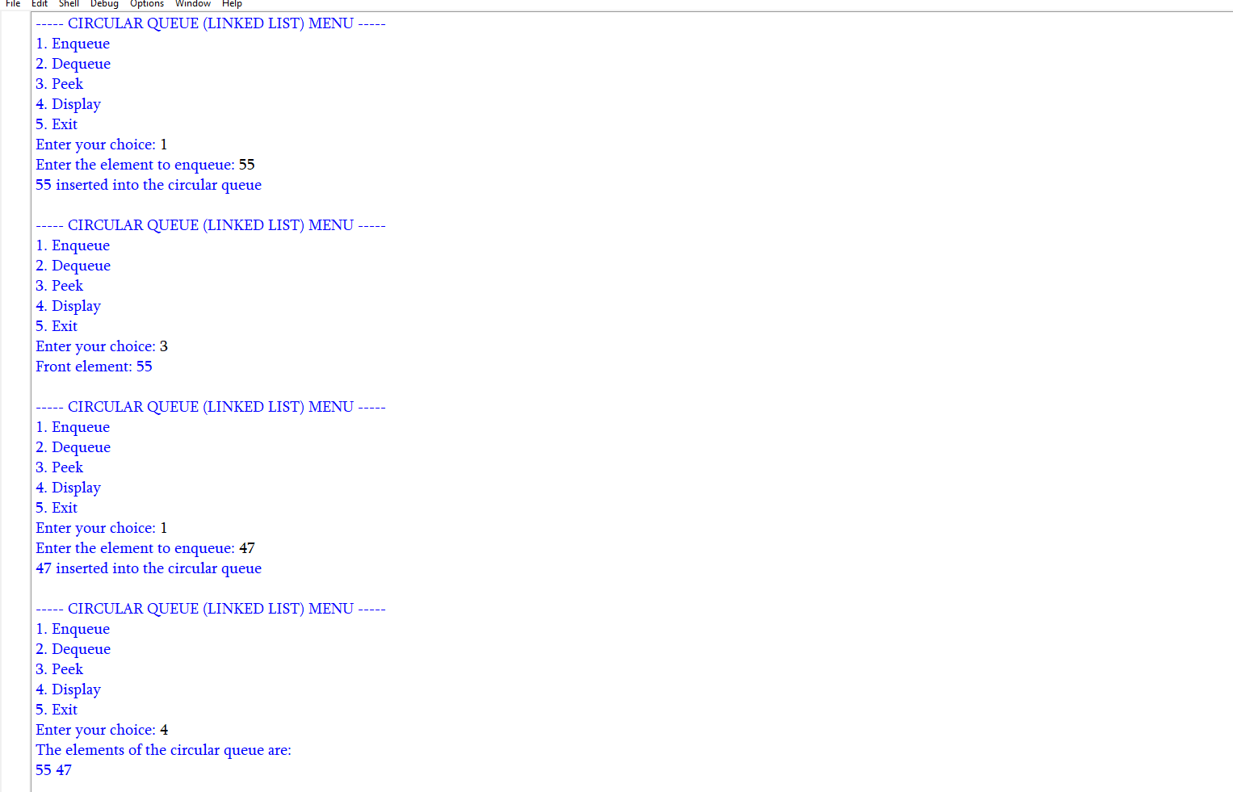

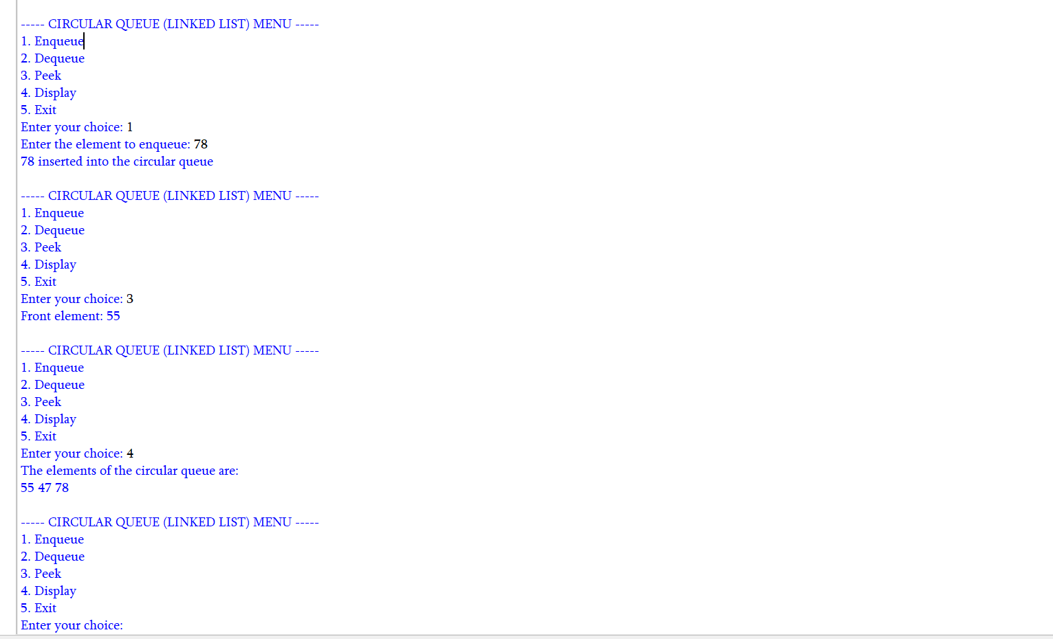

1. Error Table
S.No. | Error Type | Error / Mistake | Correction
1 | Logical Error | Not wrapping front or rear to the beginning of the array | Use modulo arithmetic, such as (rear + 1) % size.
2 | Overflow Error | Adding an element when the circular queue is full | Check the full condition before enqueueing.
3 | Runtime Error | Dequeuing from an empty queue | Check the empty condition first.

Explanation
A circular queue follows the FIFO principle and reuses array positions.
Enqueue inserts an element at the rear.
Dequeue removes an element from the front.
Modulo arithmetic wraps front and rear indices around the array.
Peek displays the front element without removing it.
Full and empty conditions are checked before operations.

LAB-8:
- ) Aim: write a python program to implement a binary tree with its operations using an array:
Program:
# BINARY TREE USING ARRAY
class BinarytreeArray:
def __init__(self, size):
self.tree = [None] * size
self.size = size
# Insert root
def set_root(self, data):
self.tree[0] = data
# Set left child
def set_left(self, parent_index, data):
child_index = 2 * parent_index + 1
if child_index < self.size:
self.tree[child_index] = data
else:
print("Index out of range")
# Set right child
def set_right(self, parent_index, data):
child_index = 2 * parent_index + 2
if child_index < self.size:
self.tree[child_index] = data
else:
print("Index out of range")
# Preorder Traversal
def preorder(self, index=0):
if index >= self.size or self.tree[index] is None:
return

print(self.tree[index], end=" ")
self.preorder(2 * index + 1)
self.preorder(2 * index + 2)
# Inorder Traversal
def inorder(self, index=0):
if index >= self.size or self.tree[index] is None:
return
self.inorder(2 * index + 1)
print(self.tree[index], end=" ")
self.inorder(2 * index + 2)
# Postorder Traversal
def postorder(self, index=0):
if index >= self.size or self.tree[index] is None:
return
self.postorder(2 * index + 1)
self.postorder(2 * index + 2)
print(self.tree[index], end=" ")
# Level-order Traversal
def level_order(self):
for value in self.tree:
if value is not None:
print(value, end=" ")
# Display Array
def display(self):
print("\nArray Representation")
for i in range(self.size):
print(f"Index {i} : {self.tree[i]}")

# MAIN PROGRAM

tree = BinarytreeArray(7)
# Create the tree
tree.set_root('A')
# Children of A
tree.set_left(0, 'B')
tree.set_right(0, 'C')
# Children of B
tree.set_left(1, 'D')
tree.set_right(1, 'E')
# Right child of C
tree.set_right(2, 'F')

# Display tree
tree.display()

# Traversals
print("\nPreorder: ", end="")
tree.preorder()
print("\nInorder: ", end="")
tree.inorder()
print("\nPostorder: ", end="")
tree.postorder()
Output:
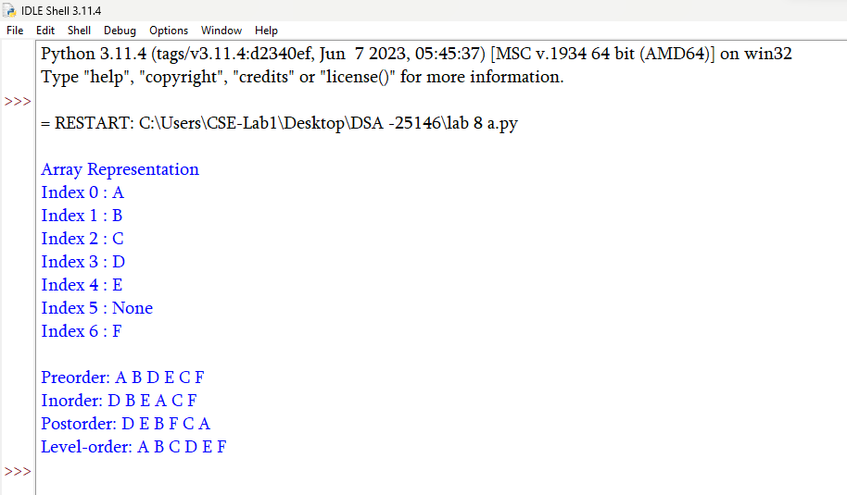

1. Error Table
S.No. | Error Type | Error / Mistake | Correction
1 | Logical Error | Incorrectly calculating child indices in an array tree | For zero-based indexing, use 2*i+1 and 2*i+2 for children.
2 | Runtime Error | Accessing an invalid index or missing node | Check index bounds or whether the node is None.

Explanation
A binary tree is a hierarchical structure in which each node has at most two children.
The array implementation stores nodes at positions determined by index formulas.
The linked-list implementation uses nodes with left and right references.
Insertion adds nodes according to the program’s chosen rules.
Traversal operations visit nodes in a specific order.
Empty-tree checks prevent operations on a tree with no root.

- ) Aim: write a python program to implement a binary tree with its operations using Linked list:
Program:
# BINARY TREE USING LINKED LIST
class Node:
def __init__(self, data):
self.data = data
self.left = None
self.right = None
# BINARY TREE CLASS
class BinaryTree:
def __init__(self):
self.root = None
# Create the binary tree
def create_tree(self):
self.root = Node('A')
# create root
# Left and right children of A
self.root.left = Node('B')
self.root.right = Node('C')
# Children of B
self.root.left.left = Node('D')
self.root.left.right = Node('E')
# Right child of C
self.root.right.right = Node('F')
# Preorder Traversal
def preorder(self, node):
if node is None:
return

print(node.data, end="")
self.preorder(node.left)
self.preorder(node.right)
# Inorder Traversal
def inorder(self, node):
if node is None:
return
self.inorder(node.left)
print(node.data, end="")
self.inorder(node.right)
# Postorder Traversal
def postorder(self, node):
if node is None:
return
self.postorder(node.left)
self.postorder(node.right)
print(node.data, end=" ")
# Level-order Traversal
def level_order(self):
if self.root is None:
return
queue = [self.root]
while queue:
node = queue.pop(0)
# Remove first node
print(node.data, end=" ")
# Add left child
if node.left is not None:
queue.append(node.left)

# Add right child
if node.right is not None:
queue.append(node.right)

# MAIN PROGRAM
tree = BinaryTree()
# Create the binary tree
tree.create_tree()
# Traversals
print("Preorder: ", end="")
tree.preorder(tree.root)
print("\nInorder: ", end="")
tree.inorder(tree.root)
print("\nPostorder: ", end="")
tree.postorder(tree.root)
print("\nLevel-order: ", end="")
tree.level_order()

Output:
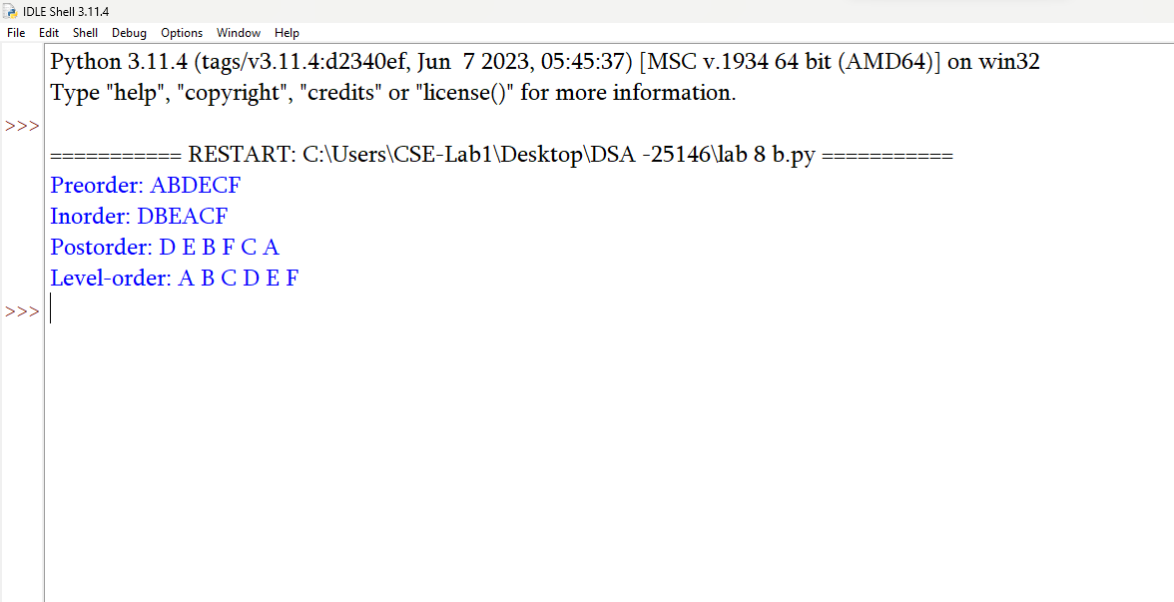

1. Error Table
S.No. | Error Type | Error / Mistake | Correction
1 | Logical Error | Incorrectly calculating child indices in an array tree | For zero-based indexing, use 2*i+1 and 2*i+2 for children.
2 | Runtime Error | Accessing an invalid index or missing node | Check index bounds or whether the node is None.

Explanation
A binary tree is a hierarchical structure in which each node has at most two children.
The array implementation stores nodes at positions determined by index formulas.
The linked-list implementation uses nodes with left and right references.
Insertion adds nodes according to the program’s chosen rules.
Traversal operations visit nodes in a specific order.
Empty-tree checks prevent operations on a tree with no root.

LAB-9:
- ) Aim: write a python program to implement a binary search tree with its operations and traversals:
Program:
class Node:
def __init__(self, data):
self.data = data
self.left = None
self.right = None

def insert(root, x):
if root is None:
return Node(x)
if x < root.data:
root.left = insert(root.left, x)
elif x > root.data:
root.right = insert(root.right, x)
else:
print("Duplicate value is not allowed.")
return root

def inorder(root):
if root is None:
return
inorder(root.left)
print(root.data, end="")
inorder(root.right)

def preorder(root):
if root is None:
return
print(root.data, end="")
preorder(root.left)
preorder(root.right)

def postorder(root):
if root is None:
return
postorder(root.left)
postorder(root.right)
print(root.data, end="")

def find_min(root):
if root is None:
return None
while root.left is not None:
root = root.left
return root

def find_max(root):
if root is None:
return None
while root.right is not None:
root = root.right
return root

def search(root, data):
if root is None:
return None
if data < root.data:
return search(root.left, data)
elif data > root.data:
return search(root.right, data)
else:
return root

def count_nodes(root):
if root is None:
return 0
return count_nodes(root.left) + count_nodes(root.right) + 1

def count_leaves(root):
if root is None:
return 0
if root.left is None and root.right is None:
return 1
return count_leaves(root.left) + count_leaves(root.right)

def count_internal(root):
if root is None:
return 0
if root.left is None and root.right is None:
return 0
return count_internal(root.left) + count_internal(root.right) + 1

def height(root):
if root is None:
return -1
left_height = height(root.left)
right_height = height(root.right)
return max(left_height, right_height) + 1

def delete(root, x):
if root is None:
print("Element not found.")
return None
if x < root.data:
root.left = delete(root.left, x)
elif x > root.data:
root.right = delete(root.right, x)
else:
#case 1 node has no children
if root.left is None and root.right is None:
root = None
#case 2 node has onle right child
elif root.left is None:
root = root.right
#case 3 node only left child
elif root.right is None :
root = root.left
#case 4 node has 2 children
else:
successor = find_min(root.right)
root.data = successor.data
root.right = delete(root.right, successor.data)
return root

def print_level(root, level):
if root is None:
return
if level == 0:
print(root.data, end="")
else:
print_level(root.left, level - 1)
print_level(root.right, level - 1)

def level_order(root):
h = height(root)
for level in range(h):
print_level(root, level)

# MAIN PROGRAM

root = None
while True:
print("\n\n******** BINARY SEARCH TREE ********")
print("1. INSERT")
print("2. PREORDER TRAVERSAL")
print("3. INORDER TRAVERSAL")
print("4. POSTORDER TRAVERSAL")
print("5. FIND MINIMUM")
print("6. FIND MAXIMUM")
print("7. SEARCH")
print("8. DELETE")
print("9. COUNT NODES")
print("10. COUNT LEAVES")
print("11. COUNT INTERNAL NODES")
print("12. HEIGHT")
print("13. LEVEL ORDER TRAVERSAL")
print("14. EXIT")

choice = int(input("Enter your choice: "))
if choice == 1:
data = int(input("Enter the data to be inserted: "))
root = insert(root, data)
print("Element inserted successfully.")
elif choice == 2:
print("Preorder Traversal:", end=" ")
if root is None:
print("Tree is empty.")
else:
preorder(root)
print()
elif choice == 3:
print("Inorder Traversal:", end=" ")
if root is None:
print("Tree is empty.")
else:
inorder(root)
print()
elif choice == 4:
print("Postorder Traversal:", end=" ")
if root is None:
print("Tree is empty.")
else:
postorder(root)
print()
elif choice == 5:
node = find_min(root)
if node is None:
print("Tree is empty.")
else:
print("Minimum element:", node.data)
elif choice == 6:
node = find_max(root)
if node is None:
print("Tree is empty.")
else:
print("Maximum element:", node.data)
elif choice == 7:
data = int(input("Enter the data to be searched: "))
node = search(root, data)
if node is None:
print("Element", data, "is not found.")
else:
print("Element", data, "is found.")
elif choice == 8:
data = int(input("Enter the data to be deleted: "))
root = delete(root, data)
elif choice == 9:
print("Number of nodes:", count_nodes(root))
elif choice == 10:
print("Number of leaf nodes:", count_leaves(root))
elif choice == 11:
print("Number of internal nodes:", count_internal(root))
elif choice == 12:
print("Height of BST:", height(root))
elif choice == 13:
print("Level Order Traversal:", end=" ")
if root is None:
print("Tree is empty.")
else:
level_order(root)
print()
elif choice == 14:
print("Program terminated.")
break
else:
print("Invalid choice. Please try again.")

Output:
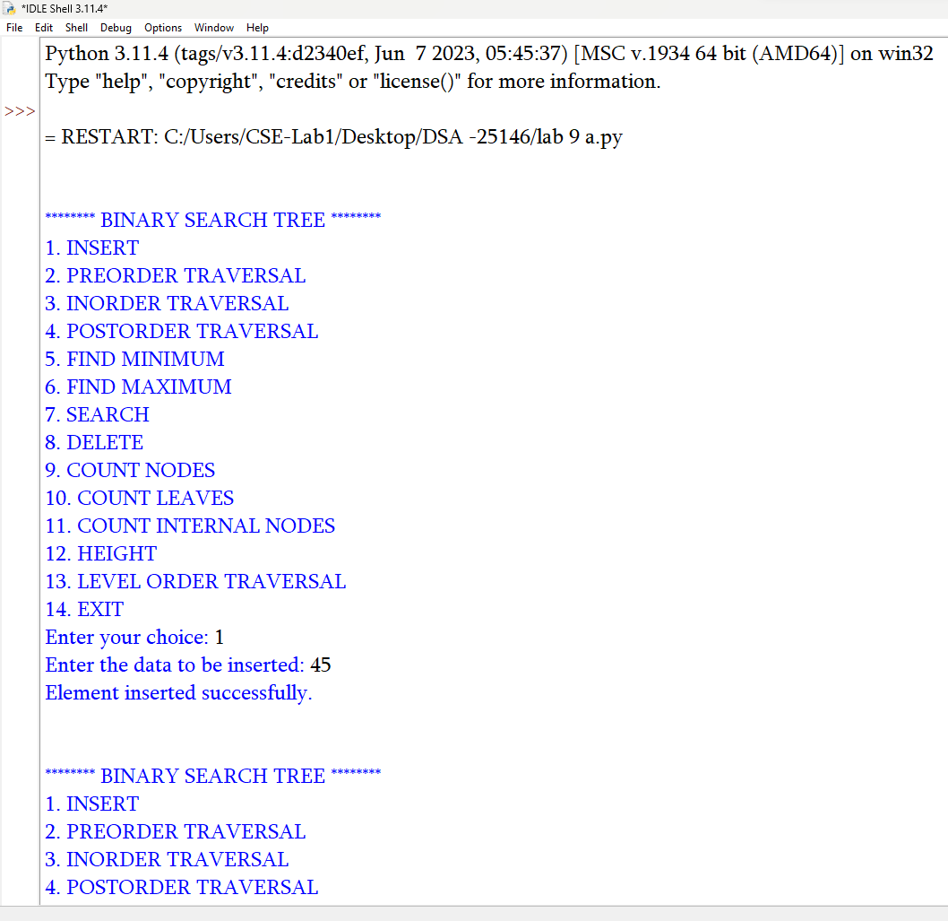
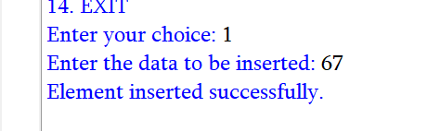

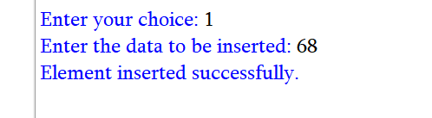

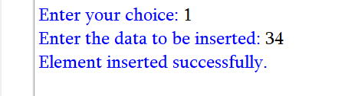

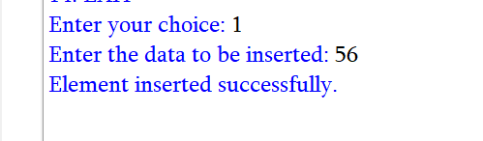

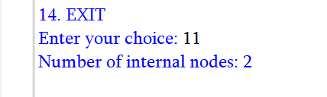

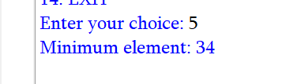
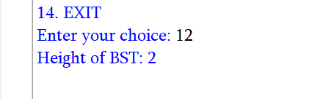

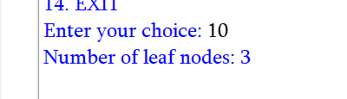

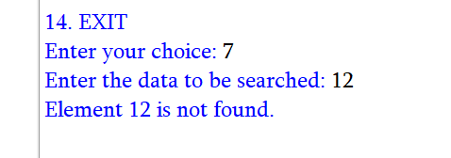

1. Error Table
S.No. | Error Type | Error / Mistake | Correction
1 | Logical Error | Placing a value in the wrong subtree | Place smaller values to the left and larger values to the right, following the code’s duplicate rule.
2 | Runtime Error | Searching for a value in an empty tree without a base case | Return safely when the current node is None.
3 | Logical Error | Incorrectly handling deletion of a node with two children | Replace the node using its inorder successor or predecessor and reconnect links.

Explanation
A binary search tree stores values according to an ordering rule.
Insertion places a value in its appropriate left or right subtree.
Search compares the target with the current node and follows the matching subtree.
Inorder traversal visits values in sorted order for a valid BST.
Minimum and maximum operations follow the leftmost and rightmost links.
Deletion handles leaf nodes, nodes with one child, and nodes with two children.

LAB-10:
- Aim: write a python program to implement an binary AVL tree with its operations
Program:
class Node:
def __init__(self, data):
self.data = data
self.left = None
self.right = None
self.height = 1
def height(root):
return root.height if root else 0
def balance(root):
return height(root.left) - height(root.right) if root else 0
def right_rotate(y):
x = y.left
t = x.right
x.right = y
y.left = t
y.height = 1 + max(height(y.left), height(y.right))
x.height = 1 + max(height(x.left), height(x.right))
return x
def left_rotate(x):
y = x.right
t = y.left
y.left = x
x.right = t
x.height = 1 + max(height(x.left), height(x.right))
y.height = 1 + max(height(y.left), height(y.right))
return y
def insert(root, data):
if not root:
return Node(data)
if data < root.data:
root.left = insert(root.left, data)
elif data > root.data:
root.right = insert(root.right, data)
else:
return root
root.height = 1 + max(height(root.left), height(root.right))
b = balance(root)
if b > 1 and data < root.left.data:
return right_rotate(root)
if b < -1 and data > root.right.data:
return left_rotate(root)
if b > 1 and data > root.left.data:
root.left = left_rotate(root.left)
return right_rotate(root)
if b < -1 and data < root.right.data:
root.right = right_rotate(root.right)
return left_rotate(root)
return root
def inorder(root):
if root:
inorder(root.left)
print(root.data, end=" ")
inorder(root.right)

def preorder(root):
if root:
print(root.data, end=" ")
preorder(root.left)
preorder(root.right)
def postorder(root):
if root:
postorder(root.left)
postorder(root.right)
print(root.data, end=" ")
def find_min(root):
if not root:
return None
while root.left:
root = root.left
return root.data
def find_max(root):
if not root:
return None
while root.right:
root = root.right
return root.data
def search(root, key):
if not root or root.data == key:
return root
if key < root.data:
return search(root.left, key)
return search(root.right, key)
def delete(root, key):
if not root:
return root
if key < root.data:
root.left = delete(root.left, key)
elif key > root.data:
root.right = delete(root.right, key)
else:
if not root.left:
return root.right
elif not root.right:
return root.left
temp = root.right
while temp.left:
temp = temp.left
root.data = temp.data
root.right = delete(root.right, temp.data)
if not root:
return root
root.height = 1 + max(height(root.left), height(root.right))
b = balance(root)
if b > 1 and balance(root.left) >= 0:
return right_rotate(root)
if b > 1 and balance(root.left) < 0:
root.left = left_rotate(root.left)
return right_rotate(root)
if b < -1 and balance(root.right) <= 0:
return left_rotate(root)
if b < -1 and balance(root.right) > 0:
root.right = right_rotate(root.right)
return left_rotate(root)
return root
root = None
while True:
print("\n\n1.Insert 2.Inorder 3.Preorder")
print("4.Postorder 5.Find Min 6.Find Max")
print("7.Search 8.Delete 9.Exit")
ch = int(input("Enter choice: "))
if ch == 1:
x = int(input("Enter value: "))
root = insert(root, x)
elif ch == 2:
inorder(root)
elif ch == 3:
preorder(root)
elif ch == 4:
postorder(root)
elif ch == 5:
print("Minimum:", find_min(root))
elif ch == 6:
print("Maximum:", find_max(root))
elif ch == 7:
x = int(input("Enter value to search: "))
print("Found" if search(root, x) else "Not Found")
elif ch == 8:
x = int(input("Enter value to delete: "))
root = delete(root, x)
elif ch == 9:
break
else:
print("Invalid choice")

Output:

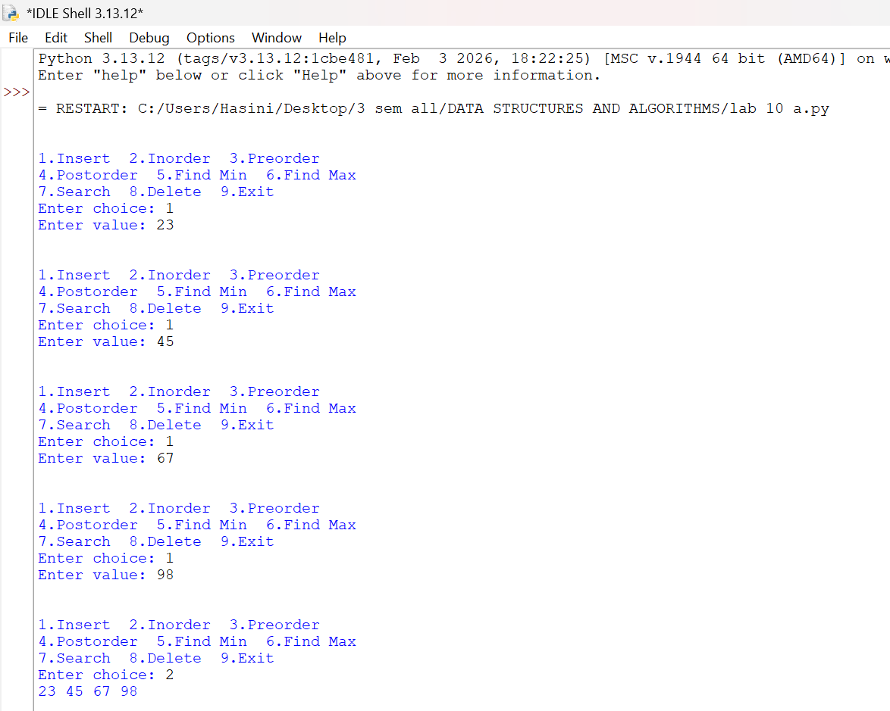

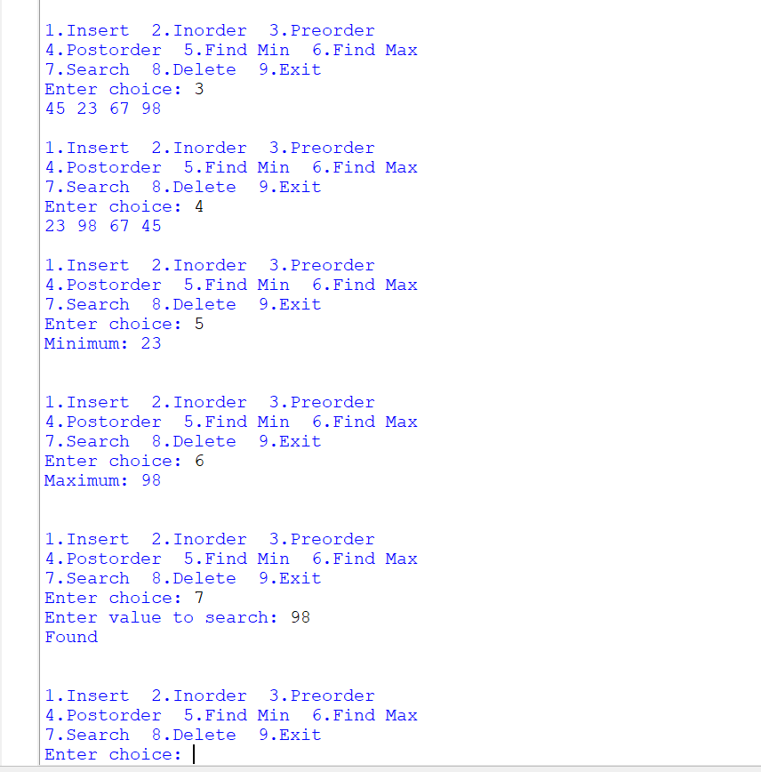
Error Table

S.No. | Error Type |  | Error / Mistake | Correction
1 | Logical Error |  | Incorrect balance factor may cause the AVL tree to become unbalanced. | Calculate the balance factor as height(root.left) - height(root.right).
2 | Logical Error |  | Incorrect rotation can violate the AVL tree's balancing rules. | Use the correct LL, RR, LR, or RL rotation.
3 | Runtime Error |  | Accessing a node that is None may cause an error. | Check whether the node exists before accessing its attributes.
4 | Logical Error |  | Deleting a node without updating heights can make the AVL tree unbalanced. | Update node heights and rebalance the tree after deletion.
5 | Logical Error |  | Searching for a value that does not exist may return None. | Display Not Found when the search returns None.
6 | Logical Error |  | Finding the minimum or maximum in an empty tree returns None. | Check whether the tree is empty before displaying the result.
7 | Input Error |  | Entering a non-integer value for the menu choice may cause a ValueError. | Enter a valid integer for the menu choice.

Explanation
- AVL Tree: A self-balancing Binary Search Tree in which the balance factor of every node is -1, 0, or +1.
- Insertion and Rotations: Insertion adds a node according to BST rules. Rotations (LL, RR, LR, RL) maintain the balance of the tree.
- Traversal Operations: Inorder visits Left → Root → Right, Preorder visits Root → Left → Right, and Postorder visits Left → Right → Root.
- Find Minimum and Maximum: The minimum value is found at the leftmost node, and the maximum value is found at the rightmost node.
- Search Operation: Searches for a given value by comparing it with the current node and moving left or right accordingly.
- Delete Operation: Removes the specified node, updates the heights, and performs rotations when necessary to maintain AVL tree balance.

